

Task Title: Purchasing Notebooks

# OALCF Cover Sheet – Practitioner Copy

**Learner Name: __________________________________________**

**Date Started: ___________________________________________**

**Date Completed: _________________________________________**

| **Goal Path:** | Employment | Apprenticeship |
| --- | --- | --- |
| Secondary School | Post Secondary | Independence |

**Successful Completion:**  Yes No

**Task Description:** The learner will determine how many notebooks they can purchase for $20.

**Main Competency/Task Group/Level Indicator:**

* Understand and Use Numbers/Manage money/C1.1

**Materials Required:**

* Pen/pencil and paper and/or digital device
* Calculator or digital device with calculator function (optional)

# Learner Information

A student wishes to buy as many notebooks as possible for $20.00. The local office supply store is having a “tax free” sale day.

Scan the “Notebooks” flyer.

**Notebooks** 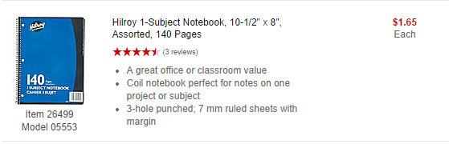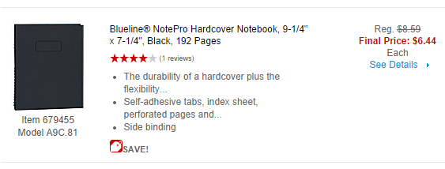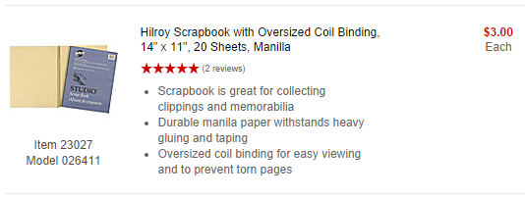

# Work Sheet

**Task 1: Calculate how many Hilroy 1-Subject Notebooks you can buy for $20.00.**

Answer:

**______________________________________________________**

**Task 2: Calculate how many Blueline NotePro Hardcover Notebooks you can buy for twenty dollars.**

Answer:

**______________________________________________________**

**Task 3: Calculate how many Hilroy Scrapbook Notebooks you can buy for $20.00.**

Answer:

**______________________________________________________**

# Answers

**Task 1: Calculate how many Hilroy 1-Subject Notebooks you can buy for $20.00.**

Answer:

$20 ÷ 1.65 = 12.12

You can buy 12 notebooks for $20.

**Task 2: Calculate how many Blueline NotePro Hardcover Notebooks you can buy for twenty dollars.**

Answer:

$20 ÷ 6.44 = 3.11

You can buy 3 notebooks for $20.

**Task 3: Calculate how many Hilroy Scrapbook Notebooks you can buy for $20.00.**

Answer:

$20 ÷ 3.00 = 6.67

You can buy 6 notebooks for $20.

# Performance Descriptors

| Levels | Performance Descriptors | Needs Work | Completes task with support from practitioner | Completes task independently |
| --- | --- | --- | --- | --- |
| C1.1 | adds, subtracts, multiplies and divides whole numbers and decimals |  |  |  |
|  | recognizes values in number and word format |  |  |  |
|  | identifies and performs required operation |  |  |  |
|  | follows apparent steps to reach solutions |  |  |  |
|  | interprets and represents costs using monetary symbols and decimals |  |  |  |
|  | rounds to the nearest dollar |  |  |  |
|  | uses strategies to check accuracy (e.g. estimating, using a calculator, repeating a calculation, using the reverse operation) |  |  |  |



This task: Was successfully completed Needs to be tried again

Learner Comments:

Instructor (print): Learner (print):

**__________________ _________________**