

Task Title: Read a Business Message

# OALCF Cover Sheet – Practitioner Copy

**Learner Name:___________________________________________**

**Date Started:____________________________________________**

**Date Completed: _________________________________________**

|  |  |  |
| --- | --- | --- |
| **Goal Path:** | Employment | Apprenticeship |
| Secondary School | Post Secondary | Independence |

**Successful Completion:**  Yes No

**Task Description:** Read aloud a message from a business and then answer written questions about the message.

**Main Competency/Task Group/Level Indicator:**

* Find and Use Information/Read continuous text/A1.2
* Find and Use Information/Interpret documents/A2.1
* Understand and Use Numbers/Manage time/C2.1
* Manage Learning/E.1

**Materials Required:**

* Pen/pencil and paper and/or digital device

# Notes for Practitioners/Instructors

1. Review the learner’s instructions with the learner.
2. Go over the checklist with your learner so that your learner is aware of the skills to be demonstrated.
3. Ask the learner to read the message aloud.

Help allowed: Dictionary

Adaptation: Any other message from a retail or wholesale outlet

# Learner Information

Messages are often taken for colleagues at work. It is important that they are accurately understood, recorded and shared.

Read the business message from Kwik Kopy Printing out loud to your instructor.

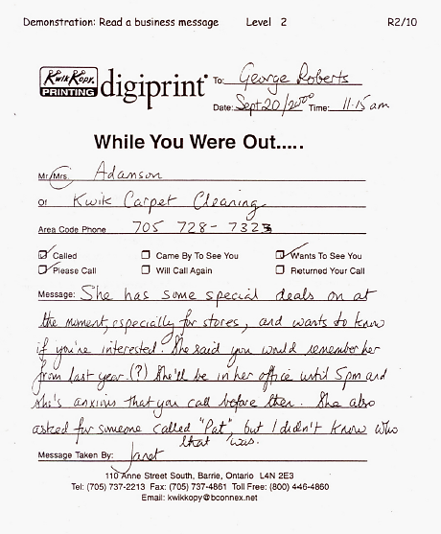

# Work Sheet

**Task 1: Who took the message?**

Answer:

**______________________________________________________**

**Task 2: How did she get this message?**

Answer:

**______________________________________________________**

**Task 3: Who is the message for?**

Answer:

**______________________________________________________**

**Task 4: Who is the message from?**

Answer:

**______________________________________________________**

**Task 5: When was the message left?**

Answer:

**______________________________________________________**

**Task 6: What is the main purpose of this message?**

Answer:

**______________________________________________________**

**Task 7: What do you think the special deal is about?**

Answer:

**______________________________________________________**

**Task 8: When does George have to return the call?**

Answer:

**______________________________________________________**

**Task 9: Do you think this message is clear? Why or why not?**

Answer:

**______________________________________________________**

Learner’s Self-Reflection

I recognized that this was a telephone message. Yes ❑ No ❑

I knew who took this message and who this message was for. Yes ❑ No ❑

I knew what had to be done. Yes ❑ No ❑

I could read all the names on this message. Yes ❑ No ❑

I found it easy to read this message. Yes ❑ No ❑

I answered __ out of 9 questions correctly. Yes ❑ No ❑

Learner Comments:

# Answers

**Task 1: Who took the message?**

Answer: Janet

**Task 2: How did she get this message?**

Answer: By phone

**Task 3: Who is the message for?**

Answer: George Roberts

**Task 4: Who is the message from?**

Answer: Mrs. Adamson

**Task 5: When was the message left?**

Answer: 11:15am

**Task 6: What is the main purpose of this message?**

Answer: To tell George about special deals and see if he’s interested.

**Task 7: What do you think the special deal is about?**

Answer: Carpet cleaning

**Task 8: When does George have to return the call?**

Answer: Before 5pm

**Task 9: Do you think this message is clear? Why or why not?**

Answer: Answer will vary depending on the learner. We don’t know what the special deal is and we don’t know who Pat is. These things are both unclear based on this message.

# Performance Descriptors

| Levels | Performance Descriptors | Needs Work | Completes task with support from practitioner | Completes task independently |
| --- | --- | --- | --- | --- |
| A1.2 | follows the main events of informational texts |  |  |  |
|  | scans text to locate information |  |  |  |
|  | locates multiple pieces of information in simple texts |  |  |  |
|  | makes low level inferences |  |  |  |
| A2.1 | interprets brief text |  |  |  |
|  | locates specific details in simple documents |  |  |  |
|  | scans to locate specific details |  |  |  |
| C2.1 | understands and uses common date formats |  |  |  |
|  | represents dates and times using standard conventions |  |  |  |
| E.1 | begins to monitor own learning |  |  |  |
|  | uses feedback to improve performance |  |  |  |

This task: Was successfully completed Needs to be tried again

Learner Comments:

Instructor (print): Learner (print):

**__________________ _________________**