

Task Title: Read a Clothing Label to Identify Washing Instructions

# OALCF Cover Sheet – Practitioner Copy

**Learner Name: __________________________________________**

**Date Started: ___________________________________________**

**Date Completed: _________________________________________**

|  |  |  |
| --- | --- | --- |
| **Goal Path:** | Employment | Apprenticeship |
| Secondary School | Post Secondary | Independence |

**Successful Completion:**  Yes No

**Task Description:** The learner will read clothing laundry labels to learn about cleaning instructions.

**Main Competency/Task Group/Level Indicator:**

* Find and Use Information/Interpret documents/A2.1

**Materials Required:**

* Pen/pencil and paper and/or digital device

# Learner Information

Clothing laundry labels, in symbol and note form, help you clean clothes. Proper cleaning will help your clothes last longer.

Scan “Label 1” and “Label 2”.

**Label 1 Label 2**

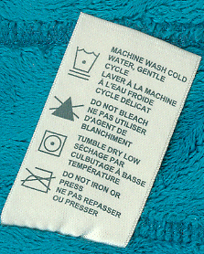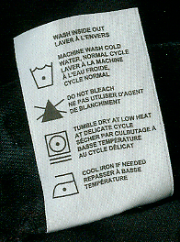

# Work Sheet

**Task 1: According to Label 1, what water temperature should you use to wash this item of clothing?**

Answer:

**______________________________________________________**

**Task 2: According to Label 1, how should you dry this item of clothing?**

Answer:

**______________________________________________________**

**Task 3: What cycle should you use to wash the item of clothing with Label 2?**

Answer:

**______________________________________________________**

**Task 4: According to Label 2, what cycle should you use to dry this item of clothing?**

Answer:

**______________________________________________________**

**Task 5: What temperature of iron can you use on the item of clothing with Label 2?**

Answer:

**______________________________________________________**

# Answers

**Task 1: According to Label 1, what water temperature should you use to wash this item of clothing?**

Answer: Cold water

**Task 2: According to Label 1, how should you dry this item of clothing?**

Answer: Tumble dry (low)

**Task 3: What cycle should you use to wash the item of clothing with Label 2?**

Answer: Normal cycle

**Task 4: According to Label 2, what cycle should you use to dry this item of clothing?**

Answer: Delicate cycle

**Task 5: What temperature of iron can you use on the item of clothing with Label 2?**

Answer: Cool iron

# Performance Descriptors

| Levels | Performance Descriptors | Needs Work | Completes task with support from practitioner | Completes task independently |
| --- | --- | --- | --- | --- |
| A2.1 | scans to locate specific details |  |  |  |
|  | interprets brief text and common symbols |  |  |  |
|  | locates specific details in simple documents, such as labels and signs |  |  |  |
|  | requires support to identify sources and to evaluate and integrate information |  |  |  |



This task: Was successfully completed Needs to be tried again

Learner Comments:

Instructor (print): Learner (print):

**__________________ _________________**

Skill-Building Activities

Laundromat Operator Demonstrator:

<http://lbsold.monikadesigns.com/PDFS/Laundromat_Operator_Demo.pdf>

Laundry Guide to Common Care Symbols:

<https://www.textileaffairs.com/lguide.htm>