

Task Title: Read Everyday Flyers 1

# OALCF Cover Sheet – Practitioner Copy

**Learner Name: __________________________________________**

**Date Started: ___________________________________________**

**Date Completed: _________________________________________**

|  |  |  |
| --- | --- | --- |
| **Goal Path:** | Employment | Apprenticeship |
| Secondary School | Post Secondary | Independence |

**Successful Completion:**  Yes No

**Task Description:** The learner will read and interpret a Halloween Carnival flyer to answer questions.

**Main Competency/Task Group/Level Indicator:**

* Find and Use Information/Interpret documents/A2.1
* Communicate Ideas and Information/Write continuous text/B2.1

**Materials Required:**

* Pen/pencil and paper and/or digital device

# Learner Information

Individuals receive flyers and invitations for parties and events.

Read the Halloween Flyer.

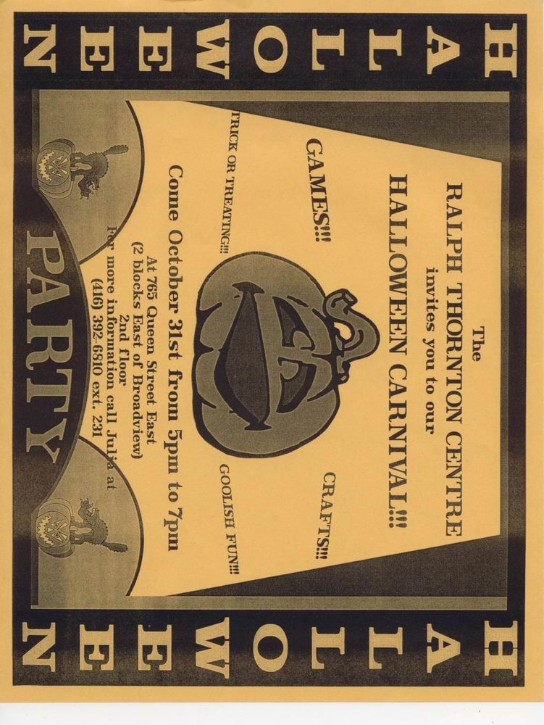**Halloween Flyer**

Work Sheet

**Task 1: What is the purpose of this flyer?**

Answer:

**______________________________________________________**

**Task 2: When is the party?**

Answer:

**______________________________________________________**

**Task 3: What time is the party being held?**

Answer:  
**______________________________________________________**

**Task 4: Where is the party happening?**

Answer:  
**______________________________________________________**

**Task 5: List two things a child can do at this party.**

Answer:

**______________________________________________________**

**Task 6: Community centres often have parties on Halloween night because they feel it is safer than going door-to-door. Do you feel it is unsafe for children to go door-to-door? Give 2 reasons for your answer.**

Answer:

**______________________________________________________**

Answers

**Task 1: What is the purpose of this flyer?**

Answer: to give details about a Halloween Carnival and invite people to attend

**______________________________________________________**

**Task 2: When is the party?**

Answer: October 31

**______________________________________________________**

**Task 3: What time is the party being held?**

Answer: from 5 pm to 7 pm  
**______________________________________________________**

**Task 4: Where is the party happening?**

Answer: the Ralph Thornton Centre, learner may include address (765 Queen Street East)  
**______________________________________________________**

**Task 5: List two things a child can do at this party.**

Answer: any two of; games, crafts, trick or treating, goolish fun

**______________________________________________________**

**Task 6: Community centres often have parties on Halloween night because they feel it is safer than going door-to-door. Do you feel it is unsafe for children to go door-to-door? Give 2 reasons for your answer.**

Answer: Answers will vary.

**______________________________________________________**

Performance Descriptors

| **Levels** | **Performance Descriptors** | **Needs Work** | **Completes task with support from practitioner** | **Completes task independently** |
| --- | --- | --- | --- | --- |
| A2.1 | Scans to locate specific details |  |  |  |
|  | Interprets brief text and common symbols |  |  |  |
|  | Locates specific details in simple documents, such as labels and signs |  |  |  |
|  | Identifies how lists are organized (e.g. sequential, chronological, alphabetical |  |  |  |
| B2.1 | Conveys simple ideas and factual information |  |  |  |
|  | Uses sentence structure, upper and lower case, and basic punctuation |  |  |  |
|  | Uses highly familiar vocabulary |  |  |  |

This task: Was successfully completed        Needs to be tried again

**Learner Comments:**

Instructor (print): Learner (print):

**__________________                                         _________________**