

Task Title: Respond to an Invitation

# OALCF Cover Sheet – Practitioner Copy

**Learner Name: __________________________________________**

**Date Started: ___________________________________________**

**Date Completed: _________________________________________**

|  |  |  |
| --- | --- | --- |
| **Goal Path:** | Employment | Apprenticeship |
| Secondary School | Post Secondary | Independence |

**Successful Completion:**  Yes No

**Task Description:** The learner will read a party invitation, enter the information on a calendar, and draft an email reply.

**Main Competency/Task Group/Level Indicator:**

* Find and Use Information/Interpret documents/A2.1
* Communicate Ideas and Information/Write continuous text/B2.1

**Materials Required:**

* Pen/pencil and paper and/or digital device

# Learner Information

People often receive invitations to special occasions. Invitations usually require a response.

Scan the “50th Anniversary Party” invitation and “September 2025” calendar.

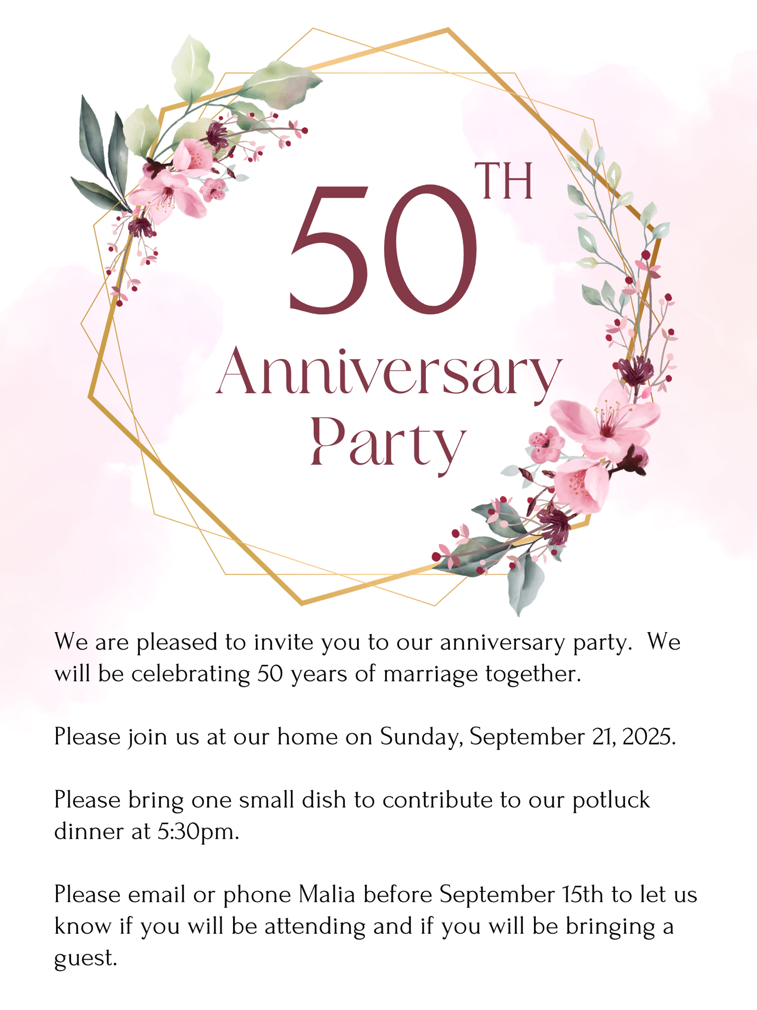



# Work Sheet

**Task 1: On the invitation, circle the date of the party. If you are doing this task online, write the date below.**

Answer:

**______________________________________________________**

**Task 2: On the calendar, write “anniversary party” on the date of the party.**

Answer: No written response required here.

Task completed: Yes:

_____________________________________________________________

**Task 3: On the calendar, write “respond to invitation” on the last day you can respond.**

Answer: No written response required here.

Task completed: Yes:

_____________________________________________________________

**Task 4: What are you expected to bring with you to the party?**

Answer:

**______________________________________________________**

**Task 5: Draft a response email including**

* **Your name and date you are sending the email**
* **Yes, you are able to attend the party**
* **You will bring cheese and crackers**
* **You will be late and arrive at 6:30pm**
* **You will be bringing your partner with you**

Answer:

**______________________________________________________**

# Answers

**Task 1: On the invitation, circle the date of the party. If you are completing this activity online, write the date below.**

Answer: Sunday, September 21, 2025, should be circled or written.

**Task 2: On the calendar, write “anniversary party” on the date of the party.**

Answer: “Anniversary party” should be written on September 21.

**Task 3: On the calendar, write “respond to invitation” on the last day you can respond.**

Answer: “Respond to invitation” should be written on September 14.

**Task 4: What are you expected to bring with you to the party?**

Answer: A dish for the potluck

**Task 5: Draft a response email including**

* **Yes, you are able to attend the party**
* **You will bring cheese and crackers**
* **You will be late and arrive at 6:30pm**
* **You will be bringing your partner with you**

Answers will vary. A sample response is:

September 14, 2025

Dear Malia,

Thank you for the anniversary party invitation. I will be attending with my husband. Unfortunately, we will be late. We will arrive around 6:30pm. I will bring cheese and crackers for the potluck.

I look forward to seeing you,

Sarah

# Performance Descriptors

| Levels | Performance Descriptors | Needs Work | Completes task with support from practitioner | Completes task independently |
| --- | --- | --- | --- | --- |
| A2.1 | scans to locate specific details |  |  |  |
|  | interprets brief text and common symbols |  |  |  |
|  | locates specific details in simple documents, such as labels and signs |  |  |  |
| B2.1 | writes simple texts to request, remind or inform |  |  |  |
|  | conveys simple ideas and factual information |  |  |  |
|  | demonstrates a limited understanding of sequence |  |  |  |
|  | uses sentence structure, upper and lower case and basic punctuation |  |  |  |
|  | uses highly familiar vocabulary |  |  |  |

This task: Was successfully completed Needs to be tried again

Learner Comments:

Instructor (print): Learner (print):

**__________________ _________________**