

Task Title: Shopping at Pharmasave

# OALCF Cover Sheet – Practitioner Copy

**Learner Name: __________________________________________**

**Date Started: ___________________________________________**

**Date Completed: _________________________________________**

|  |  |  |
| --- | --- | --- |
| **Goal Path:** | Employment | Apprenticeship |
| Secondary School | Post Secondary | Independence |

**Successful Completion:**  Yes No

**Task Description:** The learner will review a flyer and calculate the total cost of various items at Pharmasave including sales tax.

**Main Competency/Task Group/Level Indicator:**

* Find and Use Information/Interpret documents/A2.1
* Communicate Ideas and Information/Manage money/C1.2

**Materials Required:**

* Pen/pencil and paper and/or digital device
* Calculator or digital device with calculator function

# Learner Information

Reviewing store flyers and calculating the total cost of purchases in advance can help you track expenses and stay within your budget.

Review the Pharmasave flyer.

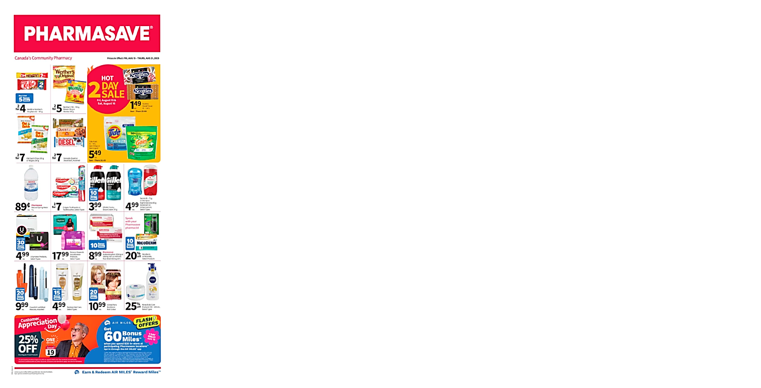

# Work Sheet

**Task 1: Calculate the total cost of**

* **4 KitKat bars**
* **4 bags of Old Dutch chips**

**These snack foods will have HST (13%) added to the price.**

Answer:

**______________________________________________________**

**Task 2: Calculate the total cost of**

* **1 package of Tide pods**
* **2 tubes of Colgate toothpaste**
* **4 boxes of Scotties facial tissue**

**You are making your purchases on Saturday, August 16. These items will all have HST (13%) added to the price.**

Answer:

**______________________________________________________**

**Task 3: Calculate the total cost of two bottles of Acetaminophen. This item will have HST (13%) added to the price.**

Answer:

**______________________________________________________**

**Task 4: Calculate the total cost of all purchases in Tasks 1, 2, and 3.**

Answer:

**______________________________________________________**

# Answers

**Task 1: Calculate the total cost of**

* **4 KitKat bars**
* **4 bags of Old Dutch chips**

**These snack foods will have HST (13%) added to the price.**

Answer:

$8.00 +$14.00 = $22.00

$22.00 x 0.13 = $2.86

$22.00 + $2.86 = $24.86

**Task 2: Calculate the total cost of**

* **1 package of Tide pods**
* **2 tubes of Colgate toothpaste**
* **4 boxes of Scotties facial tissue**

**You are making your purchases on Saturday, August 16. These items will all have HST (13%) added to the price.**

Answer:

$5.49 + $7.00 + $5.96 = $18.45

$18.45 x 0.13 = $2.40

$18.45 + $2.40 = $20.85

**Task 3: Calculate the total cost of two bottles of Acetaminophen. This item will have HST (13%) added to the price.**

Answer:

$8.99 x 2 = $17.98

$17.98 x 0.13 = $2.34

$17.98 + $2.34 = $20.32

**Task 4: Calculate the total cost of all purchases in Tasks 1, 2, and 3.**

Answer: $24.86 + $20.85 + $20.32 = $66.03

# Performance Descriptors

| Levels | Performance Descriptors | Needs Work | Completes task with support from practitioner | Completes task independently |
| --- | --- | --- | --- | --- |
| A2.1 | scans to locate specific details |  |  |  |
|  | interprets brief text and common symbols |  |  |  |
|  | locates specific details in simple documents, such as lists or signs |  |  |  |
|  | requires support to identify sources and to evaluate and integrate information |  |  |  |
| C1.2 | calculates using numbers expressed as whole numbers, fractions, decimals, percentages and integers |  |  |  |
|  | calculates percentages |  |  |  |
|  | chooses and performs required operation(s); may make inferences to identify required operation(s) |  |  |  |
|  | selects appropriate steps to reach solutions |  |  |  |
|  | represents costs and rates using monetary symbols, decimals and percentages |  |  |  |
|  | interprets, represents and converts amounts using whole numbers, decimals, percentages, ratios and simple, common fractions (e.g. 1/2, 1/4) |  |  |  |
|  | uses strategies to check accuracy (e.g. estimating, using a calculator, repeating a calculation, using the reverse operation) |  |  |  |

This task: Was successfully completed Needs to be tried again

Learner Comments:

Instructor (print): Learner (print):

**__________________ _________________**