

Task Title: Table of Contents

# OALCF Cover Sheet – Practitioner Copy

**Learner Name: __________________________________________**

**Date Started: ___________________________________________**

**Date Completed: _________________________________________**

|  |  |  |
| --- | --- | --- |
| **Goal Path:** | Employment | Apprenticeship |
| Secondary School | Post Secondary | Independence |

**Successful Completion:**  Yes No

**Task Description:** Learner will read a table of contents to locate specific sections.

**Main Competency/Task Group/Level Indicator:**

* Find and Use Information/Interpret documents/A2.2

**Materials Required:**

* Pen/pencil and paper and/or digital device

# Learner Information

# Employees often need to review the User Guide or Manual for a product in order to identify and solve problems. Look at the “Table of Contents” for the photocopier.

# Scan the “Table of Contents” for Apex Alpha Photocopier WC 341.

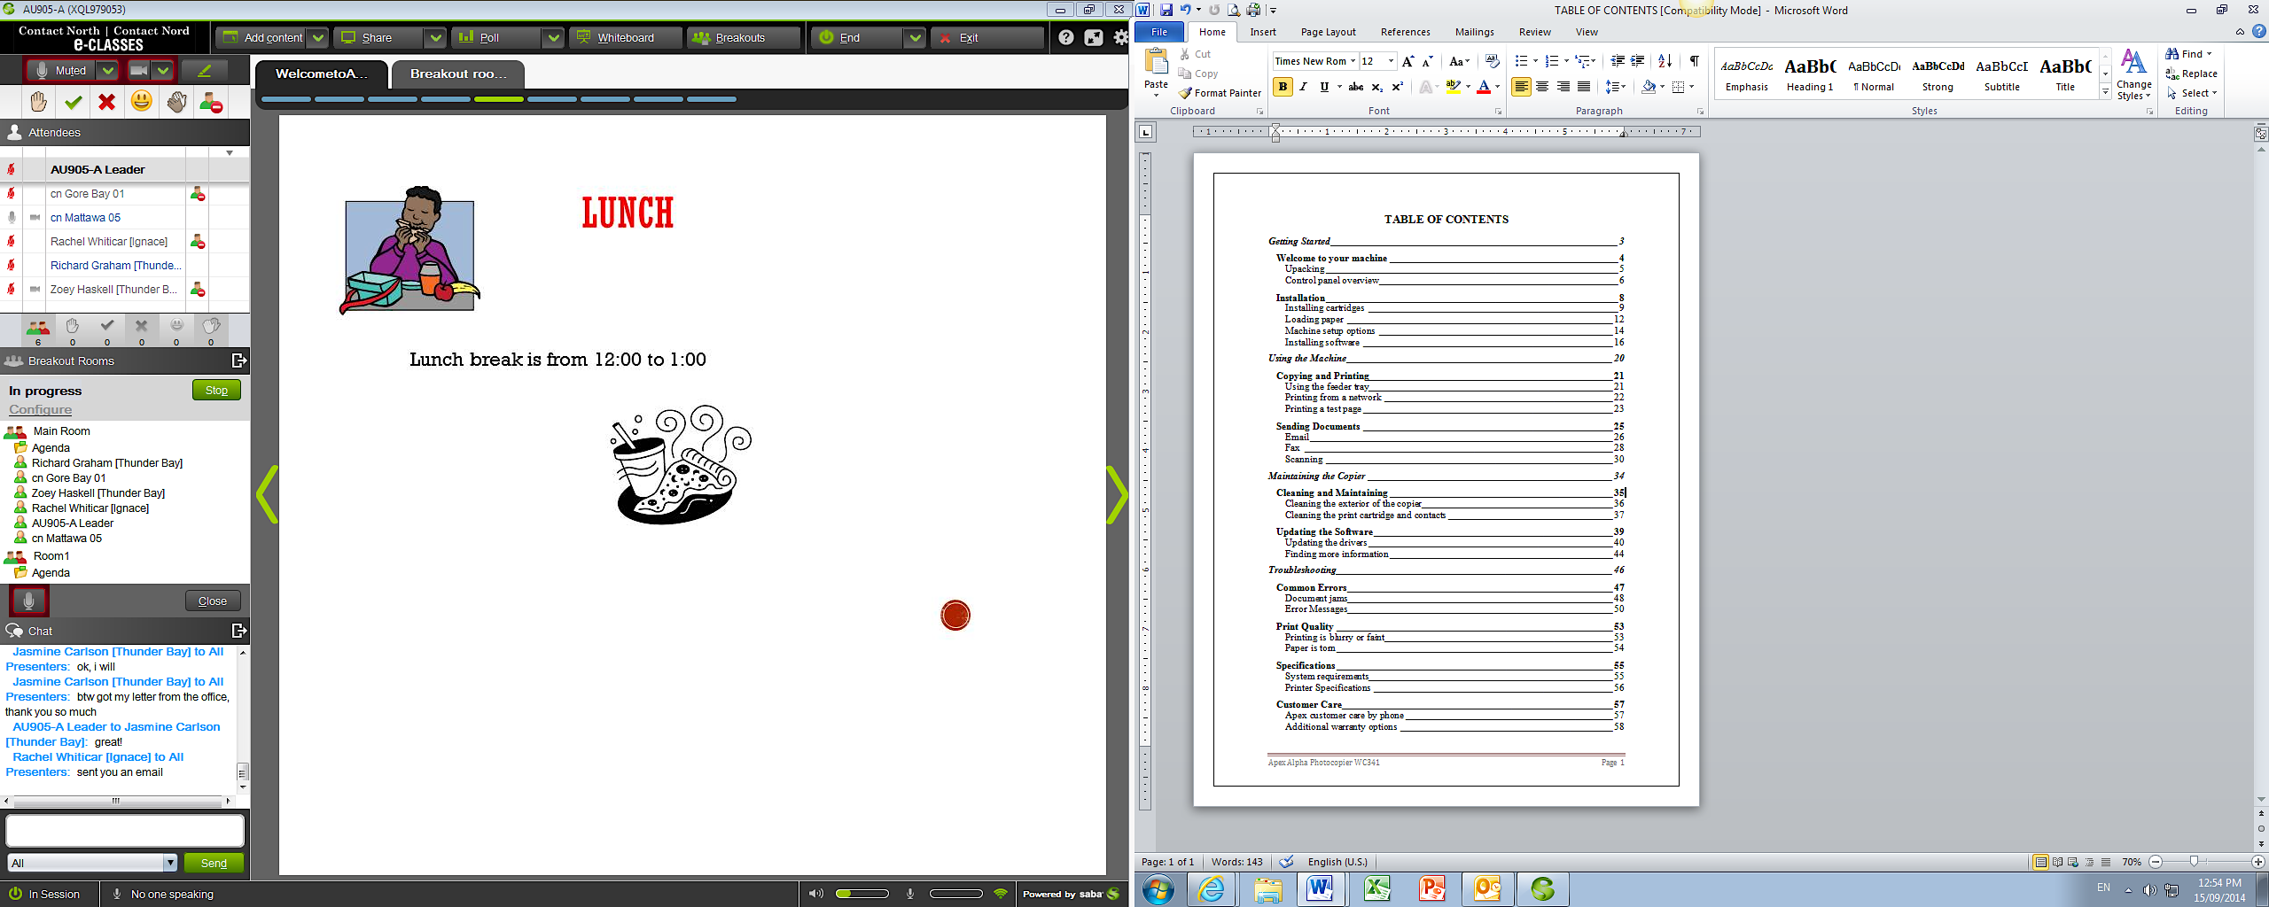

# Work Sheet

**Task 1: List the four section headings in the User’s Guide.**

Answer:

**______________________________________________________**

**Task 2: Which section contains information that will help fix an error with the photocopier?**

Answer:

**______________________________________________________**

**Task 3: List the two common errors that happen with this photocopier.**

Answer:

**______________________________________________________**

**Task 4: If this manual does not contain the specific information needed to solve the problem with the photocopier, who can be called for help?**

Answer:

**______________________________________________________**

# Answers

**Task 1: List the four section headings in the User’s Guide.**

Answer:

* Getting Started
* Using the Machine
* Maintaining the Copier
* Troubleshooting

**Task 2: Which section contains information that will help fix an error with the photocopier?**

Answer: Troubleshooting

**Task 3: List the two common errors that happen with this photocopier.**

Answer: Document jams, error messages.

**Task 4: If this manual does not contain the specific information needed to solve the problem with the photocopier, who can be called for help?**

Answer: Call (phone) Apex customer care.

# Performance Descriptors

| Levels | Performance Descriptors | Needs Work | Completes task with support from practitioner | Completes task independently |
| --- | --- | --- | --- | --- |
| A2.2 | performs limited searches using one or two search criteria |  |  |  |
|  | extracts information from tables and forms |  |  |  |
|  | uses layout to locate information |  |  |  |
|  | makes connections between parts of documents |  |  |  |
|  | makes low-level inferences |  |  |  |

This task: Was successfully completed Needs to be tried again

Learner Comments:

Instructor (print): Learner (print):

**__________________ _________________**