

Task Title: Tips to Reduce your Energy Bill

# OALCF Cover Sheet – Practitioner Copy

**Learner Name: __________________________________________**

**Date Started: ___________________________________________**

**Date Completed: _________________________________________**

|  |  |  |
| --- | --- | --- |
| **Goal Path:** | Employment | Apprenticeship |
| Secondary School | Post Secondary | Independence |

**Successful Completion:**  Yes No

**Task Description:** The learner will review a document listing ways to reduce energy bills and answer questions.

**Main Competency/Task Group/Level Indicator:**

* Find and Use Information/Read continuous text/A1.2

**Materials Required:**

* Pen/pencil and paper and/or digital device

# Learner Information

Electricity is expensive and it is always helpful to learn ways to minimize costs.

Scan “Top Ten Fastest, Easiest and Best Ever Money-Saving Tips”.

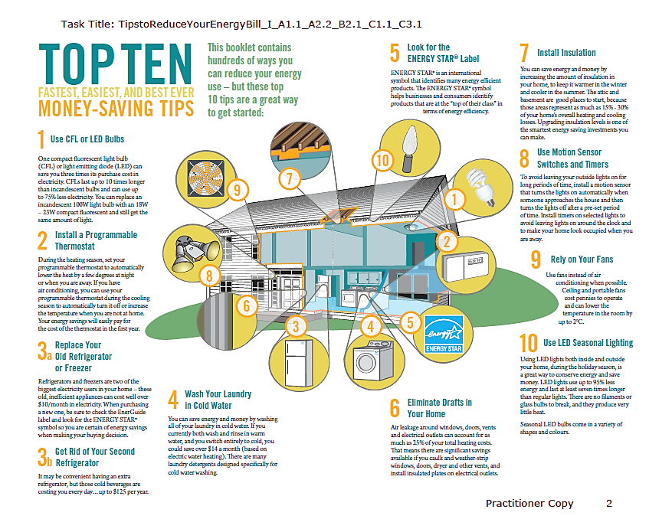

# Work Sheet

**Task 1: List five (5) ways to lower home energy costs.**

Answer:

**______________________________________________________**

**Task 2: List three (3) reasons why CFL and LED lightbulbs are better than incandescent lightbulbs.**

Answer:

**______________________________________________________**

**Task 3: What does the Energy Star label help identify?**

Answer:

**______________________________________________________**

**Task 4: If you use only cold water to wash your clothes, how much money could you save each month?**

Answer:

**______________________________________________________**

**Task 5: Explain how you can reduce drafts around windows, doors, vents and electrical outlets.**

Answer:

**______________________________________________________**

Answers

**Task 1: List five (5) ways to lower home energy costs.**

Answer: Any five of

* Use CFL or LED bulbs
* Install a programmable thermostat
* Replace your old refrigerator or freezer
* Get rid of your second refrigerator
* Wash your laundry in cold water
* Look for the Energy Star label
* Eliminate drafts in your home
* Install insulation
* Use motion sensor switches and timers
* Rely on your fans
* Use LED seasonal lighting

**Task 2: List three (3) reasons why CFL and LED lightbulbs are better than incandescent lightbulbs.**

Answer: Any three of

* Save three times their cost
* They last 10 times longer
* Use up to 75% less electricity
* You can replace a 100W light bulb with an 18W-23W CFL and get the same amount of light

**Task 3: What does the Energy Star label help identify?**

Answer: energy efficient products/products at the top of their class in terms of energy efficiency

**Task 4: If you use only cold water to wash your clothes, how much money could you save each month?**

Answer: $14.00

**Task 5: Explain how you can reduce drafts around windows, doors, vents and electrical outlets.**

Answer: Caulk, weather-strip, and install insulated plates

# Performance Descriptors

| Levels | Performance Descriptors | Needs Work | Completes task with support from practitioner | Completes task independently |
| --- | --- | --- | --- | --- |
| A1.2 | scans text to locate information |  |  |  |
|  | locates multiple pieces of information in simple texts |  |  |  |
|  | makes low-level inferences |  |  |  |
|  | makes connections between sentences and between paragraphs in a single text |  |  |  |
|  | reads more complex texts to locate a single piece of information |  |  |  |
|  | follows the main events of descriptive, narrative and informational texts |  |  |  |
|  | obtains information from detailed reading |  |  |  |
|  | begins to identify sources and evaluate information |  |  |  |

This task: Was successfully completed Needs to be tried again

Learner Comments:

Instructor (print): Learner (print):

**__________________ _________________**