

Task Title: Understanding Calculations in Carpentry

# OALCF Cover Sheet – Practitioner Copy

**Learner Name: __________________________________________**

**Date Started: ___________________________________________**

**Date Completed: _________________________________________**

|  |  |  |
| --- | --- | --- |
| **Goal Path:** | Employment | Apprenticeship |
| Secondary School | Post Secondary | Independence |

**Successful Completion:**  Yes No

**Task Description:** The learner will make calculations based on carpentry task information.

**Main Competency/Task Group/Level Indicator:**

* Understand and Use Numbers/Use measures/C3.2

**Materials Required:**

* Pen/pencil and paper and/or digital device
* Calculator or digital device with calculator function

# Learner Information

Carpenters make many calculations including determining where structures can be built, or calculating the quantities of materials that are needed.

Worksheet

**Task 1: Deep excavations need sloping sides to keep loose material from sliding onto anyone working below. There needs to be a 3:4 ratio between the setback (x) and the depth of the excavation.**

**Calculate the setback needed for a house with a basement that requires an excavation 2.2 m deep. Round your answer to the nearest tenth.**

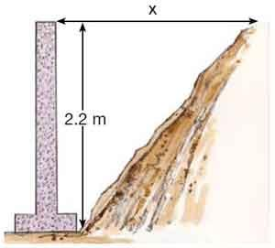

Answer:

**______________________________________________________**

**Task 2: Cleats need to be placed every three feet. Two stakes are needed for each cleat. One additional stake is placed in each corner. Calculate the number of cleats and stakes needed to build footing ladders for the foundation shown below.**

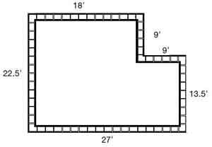

Answer:

**______________________________________________________**

**Task 3: Cleats are purchased in bundles of 5. Stakes are purchased in bundles of 12. Calculate the number of bundles of each that are needed for this project. You cannot purchase partial bundles.**

Answer:

**______________________________________________________**

# Answers

**Task 1: Deep excavations need sloping sides to keep loose material from sliding onto anyone working below. There needs to be a 3:4 ratio between the setback (x) and the depth of the excavation.** **Calculate the setback needed for a house with a basement that requires an excavation 2.2 m deep. Round your answer to the nearest tenth.**



Answer:

x : 2.2 = 3 : 4

4x = 3 x 2.2

4x = 6.6

4x/4 = 6.6/4

X = 1.65. The setback will be 1.7 m.

**Task 2: Cleats need to be placed every three feet. Two stakes are needed for each cleat. One additional stake is placed in each corner. Calculate the number of cleats and stakes needed to build footing ladders for the foundation shown below.**



Answer:

Total perimeter of foundation: 22.5 + 18 + 9 + 9 + 13.5 + 27 = 99 feet

Cleats: 99/3 (Cleats are placed every 3 feet) = 33 cleats are needed

Stakes:

2 stakes are needed for each cleat: 2 x 33 = 66 stakes

Additional stakes are needed in each corner: 6 corners x 1 = 6 stakes

Total stakes needed: 66 + 6 = 72 stakes are needed

**Task 3: Cleats are purchased in bundles of 5. Stakes are purchased in bundles of 12. Calculate the number of bundles of each that are needed for this project. You cannot purchase partial bundles.**

Answer:

33 cleats are needed. 33/5 = 6.6. 7 bundles need to be purchased.

72 stakes are needed. 72/12 = 6. 6 bundles need to be purchased.

# Performance Descriptors

| Levels | Performance Descriptors | Needs Work | Completes task with support from practitioner | Completes task independently |
| --- | --- | --- | --- | --- |
| C3.2 | calculates using numbers expressed as whole numbers, fractions, decimals, percentages and integers |  |  |  |
|  | understands and uses ratio and proportion |  |  |  |
|  | understands and uses formulas for finding the perimeter, area and volume of simple common shapes |  |  |  |
|  | chooses and performs required operation(s); may make inferences to identify required operation(s) |  |  |  |
|  | selects appropriate steps to reach solutions |  |  |  |
|  | interprets, represents, and converts measures using whole numbers, decimals, percentages, ratios and simple, common fractions (e.g. ½, ¼) |  |  |  |
|  | uses strategies to check accuracy (e.g. estimating, using a calculator, repeating a calculation, using the reverse operation) |  |  |  |



This task: Was successfully completed Needs to be tried again

Learner Comments:

Instructor (print): Learner (print):

**__________________ _________________**