

Task Title: Understanding Working Load Limits

# OALCF Cover Sheet – Practitioner Copy

**Learner Name: __________________________________________**

**Date Started: ___________________________________________**

**Date Completed: _________________________________________**

|  |  |  |
| --- | --- | --- |
| **Goal Path:** | Employment | Apprenticeship |
| Secondary School | Post Secondary | Independence |

**Successful Completion:**  Yes No

**Task Description:** The learner will interpret information about working load limits for ropes from a chart.

**Main Competency/Task Group/Level Indicator:**

* Find and Use Information/Interpret documents/A2.2

**Materials Required:**

* Pen/pencil and paper and/or digital device

# Learner Information

Industrial mechanics (millwrights) use working load limits to make sure the load they are lifting does not exceed safety limits.

Scan “Working Loads for Wire Ropes”.

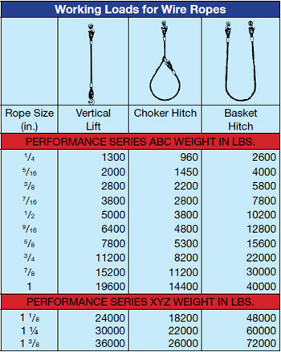

# Work Sheet

**Task 1: The supervisor tells his crew to use a basket hitch configuration to lift a 42,000-pound load. What size of wire rope should be used?**

Answer:

# **_______________________________________________**

**Task 2: The crew is using a vertical lift configuration to lift a 5,500-pound load. What size of wire rope should be used?**

Answer:

# **_______________________________________________**

**Task 3: The crew is using a vertical lift configuration to lift a 11,000-pound load. What size of wire rope should be used?**

Answer:

# **_______________________________________________**

**Task 4: The crew is using a choker hitch configuration to lift a 11,250-pound load. What size of wire rope should be used?**

Answer:

# **_______________________________________________**

# Answers

**Task 1: The supervisor tells his crew to use a basket hitch configuration to lift a 42,000-pound load. What size of wire rope should be used?**

Answer: 1 1/8-inch rope

**Task 2: The crew is using a vertical lift configuration to lift a 5,500-pound load. What size of wire rope should be used?**

Answer: 9/16-inch rope

**Task 3: The crew is using a vertical lift configuration to lift a 11,000-pound load. What size of wire rope should be used?**

Answer: ¾-inch rope

**Task 4: The crew is using a choker hitch configuration to lift a 11,250-pound load. What size of wire rope should be used?**

Answer: 1-inch rope

# Performance Descriptors

| Levels | Performance Descriptors | Needs Work | Completes task with support from practitioner | Completes task independently |
| --- | --- | --- | --- | --- |
| A2.2 | performs limited searches using one or two search criteria |  |  |  |
|  | extracts information from tables and forms |  |  |  |
|  | uses layout to locate information |  |  |  |
|  | makes connections between parts of documents |  |  |  |
|  | makes low-level inferences |  |  |  |
|  | begins to identify sources and evaluate information |  |  |  |

This task: Was successfully completed Needs to be tried again

Learner Comments:

Instructor (print): Learner (print):

**__________________ _________________**