

Task Title: Use a Floorplan to Design a Room

# OALCF Cover Sheet – Practitioner Copy

**Learner Name: __________________________________________**

**Date Started: ___________________________________________**

**Date Completed: _________________________________________**

|  |  |  |
| --- | --- | --- |
| **Goal Path:** | Employment | Apprenticeship |
| Secondary School | Post Secondary | Independence |

**Successful Completion:**  Yes No

**Task Description:** The learner will create a floor plan using furniture and room measurements.

**Main Competency/Task Group/Level Indicator:**

* Find and Use Information/Interpret documents/A2.2
* Understand and Use Numbers/Use measures/C3.1

**Materials Required:**

* Pen/pencil and paper and/or digital device
* Calculator or digital device with calculator function (optional)

# Learner Information

A floorplan can help you decide where to put furniture so that everything will fit.

Scan the “floorplan” and “furniture items and dimensions”.

**Floorplan**

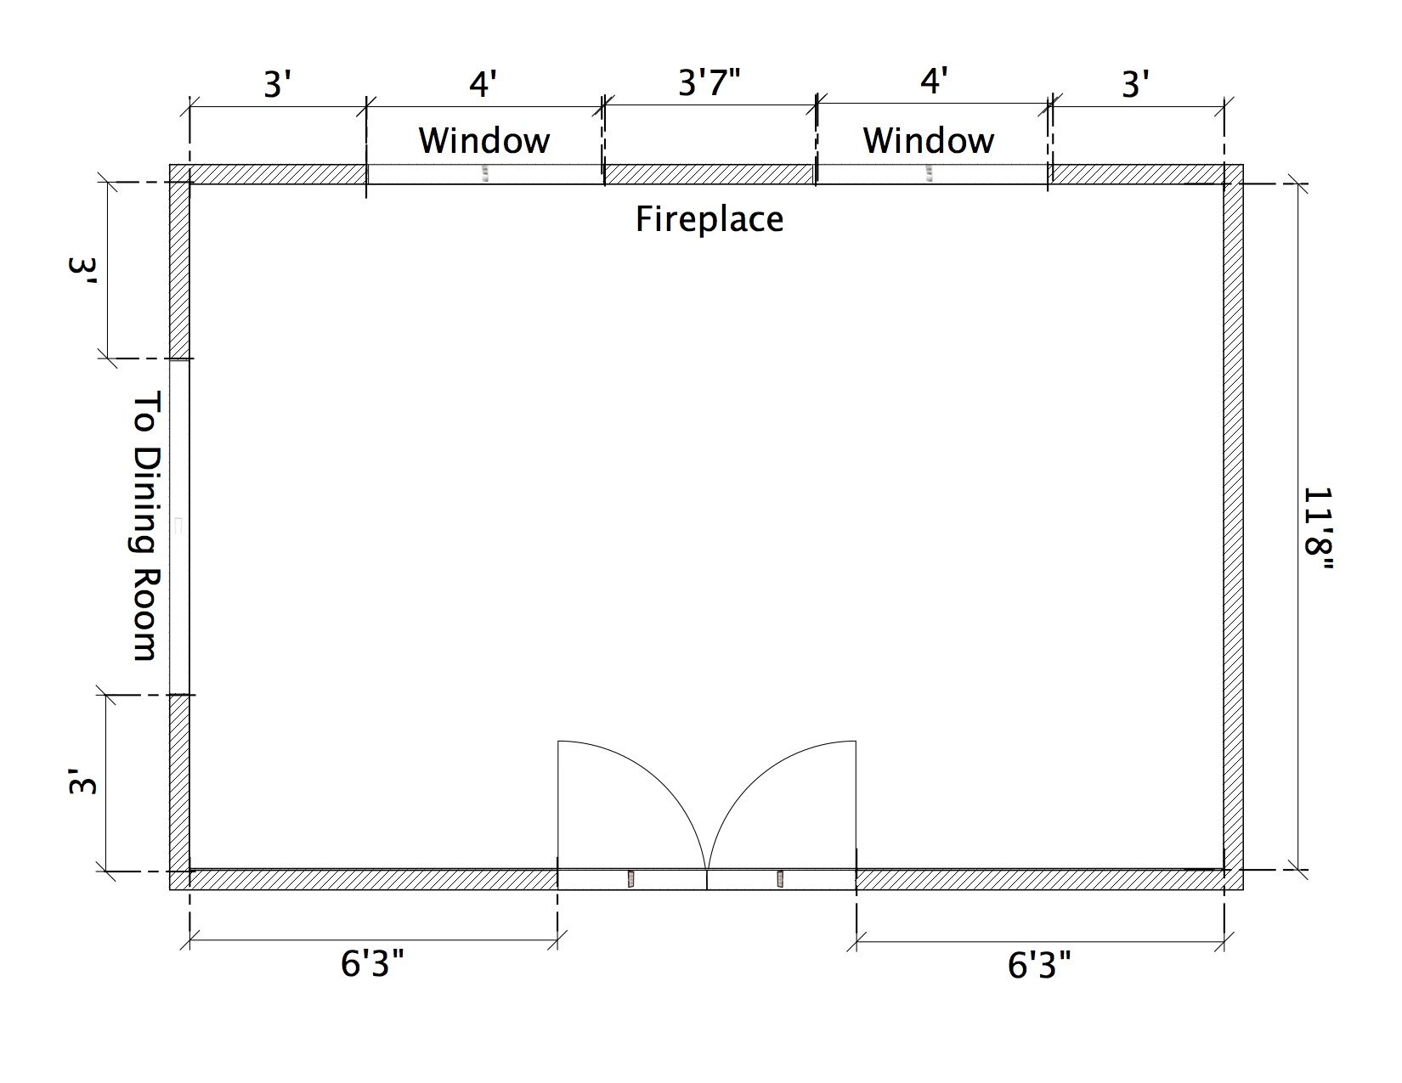

**Furniture Items and Dimensions**

|  |  |
| --- | --- |
| **Item** | **Dimensions** |
| **Couch** | 6 feet x 3 feet |
| **Loveseat** | 4 feet x 3 feet |
| **Chair** | 3 feet x 3 feet |
| **End table** | 2 feet x 2 feet |
| **Coffee table** | 3 feet by 2 feet |
| **Television stand** | 3 feet x 2 feet |
| **Bookshelf** | 2 feet wide x 1 foot deep |
| **Floor lamp** | All floor lamps have a 1-foot diameter base |
| **Dog bed** | 2 feet x 2 feet |
| **Plants** | All plants have a 1-foot diameter base |

# Work Sheet

**Task 1: Select five (5) items from the furniture list. Draw and label where you would like to put each item on the floorplan. Make sure there is at least 1 foot of empty space along each wall. Make sure furniture is not blocking windows or doorways.**

Answer: No written response required here.

Task completed: Yes:

Answers

Answers will vary.

# Performance Descriptors

| Levels | Performance Descriptors | Needs Work | Completes task with support from practitioner | Completes task independently |
| --- | --- | --- | --- | --- |
| A2.2 | extracts information from tables and forms |  |  |  |
|  | uses layout to locate information |  |  |  |
|  | makes connections between parts of documents |  |  |  |
| C3.1 | adds and subtracts whole number measurements |  |  |  |
|  | recognizes values in number and word format |  |  |  |
|  | recognizes simple, common shapes (e.g. circle, square, rectangle, triangle) |  |  |  |
|  | measure distance, length, width, height, weight, liquid volume, angles and temperature |  |  |  |
|  | makes simple estimates |  |  |  |
|  | interprets and represents measures using symbols and abbreviations (e.g. inches as “, centimeters as cm, pounds as lbs, kilograms as kilos or kg) |  |  |  |

This task: Was successfully completed Needs to be tried again

Learner Comments:

Instructor (print): Learner (print):

**__________________ _________________**