

Task Title: Verify Personal Contact Information

# OALCF Cover Sheet – Practitioner Copy

**Learner Name: __________________________________________**

**Date Started: ___________________________________________**

**Date Completed: _________________________________________**

|  |  |  |
| --- | --- | --- |
| **Goal Path:** | Employment | Apprenticeship |
| Secondary School | Post Secondary | Independence |

**Successful Completion:**  Yes No

**Task Description:** The learner will review a Canadian/Ontario Personal Tax Credits form (TD1ON) for errors.

**Main Competency/Task Group/Level Indicator:**

* Find and Use Information/Interpret documents/A2.1

**Materials Required:**

* Pen/pencil and paper and/or digital device

# Notes for Instructors/Practitioners

Print out the TD1ON 2024 form. Fill in the personal information section at the top of the form based on the learner’s information. In this task, the learner will be reviewing the form for errors. Make two errors when you fill out the form for review; for example: you may include a slightly incorrect name spelling, postal code or date of birth.

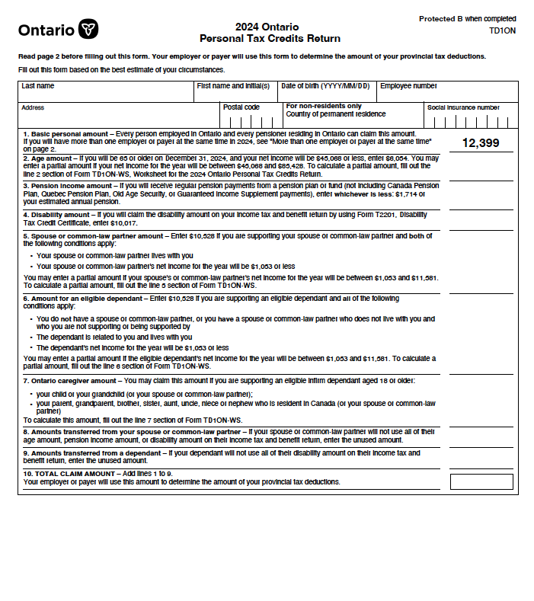

# Learner Information

Many tax and other forms and other official forms come with your personal information already filled in. It is important to make sure this information is correct.

Review the “2024 Ontario Personal Tax Credits Return” form your instructor will give you.

# Work Sheet

**Task 1: Check and correct any errors in your name.**

Answer: No written response required here.

Task completed: Yes:

**Task 2: Check and correct any errors in your address.**

Answer: No written response required here.

Task completed: Yes:

**Task 3: Check and correct any errors in your date of birth.**

Answer: No written response required here.

Task completed: Yes:

# Answers

Answers will vary.

# Performance Descriptors

| Levels | Performance Descriptors | Needs Work | Completes task with support from practitioner | Completes task independently |
| --- | --- | --- | --- | --- |
| A2.1 | scans to locate specific details |  |  |  |
|  | interprets brief text and common symbols |  |  |  |
|  | locates specific details in simple documents, such as labels and signs |  |  |  |

This task: Was successfully completed Needs to be tried again

Learner Comments:

Instructor (print): Learner (print):

**__________________ _________________**