

Task Title: Your Banking Options – Welcome to Libro

# OALCF Cover Sheet – Practitioner Copy

**Learner Name: __________________________________________**

**Date Started: ___________________________________________**

**Date Completed: _________________________________________**

|  |  |  |
| --- | --- | --- |
| **Goal Path:** | Employment | Apprenticeship |
| Secondary School | Post Secondary | Independence |

**Successful Completion:**  Yes No

**Task Description:** The learner will read a brochure about banking services offered to Libro Credit Union customers.

**Main Competency/Task Group/Level Indicator:**

* Find and Use Information/Read continuous text/A1.2

**Materials Required:**

* Pen/pencil and paper and/or digital device

# Learner Information

Credit unions and banks offer a variety of services to customers.

Read the “Welcome to Libro” pamphlet.

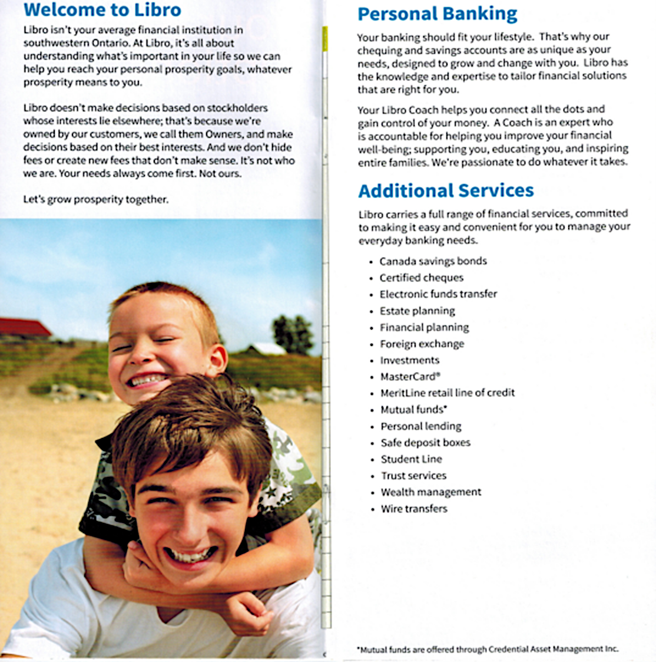**Welcome to Libro Pamphlet**

# Work Sheet

**Task 1: How does Libro Credit Union make decisions?**

Answer:

**______________________________________________________**

**Task 2: What does a Libro Coach do?**

Answer:

**______________________________________________________**

**Task 3: List five additional services Libro provides to its customers.**

Answer:

**______________________________________________________**

# Answers

**Task 1: How does Libro Credit Union make decisions?**

Answer: They make decisions based on owners’ (customers’) best interests.

**Task 2: What does a Libro Coach do?**

Answer: They help customers connect the dots and gain control of their money.

**Task 3: List five additional services Libro provides to its customers.**

Answer: Any five of: Canada savings bonds, certified cheques, electronic funds transfer, estate planning, financial planning, foreign exchange, investments, MasterCard, MeritLine retail line of credit, mutual funds, personal lending, safe deposit boxes, student line, trust services, wealth management, wire transfers.

# Performance Descriptors

| Levels | Performance Descriptors | Needs Work | Completes task with support from practitioner | Completes task independently |
| --- | --- | --- | --- | --- |
| A1.2 | scans text to locate information |  |  |  |
|  | locates multiple pieces of information in simple texts |  |  |  |
|  | reads more complex texts to locate a single piece of information |  |  |  |
|  | follows the main events of descriptive, narrative and informational texts |  |  |  |
|  | obtains information from detailed reading |  |  |  |

This task: Was successfully completed Needs to be tried again

Learner Comments:

Instructor (print): Learner (print):

**__________________ _________________**