OALCF Task Cover Sheet
Task Title: Read Everyday Flyers
Learner Name:

Date Started: Date Completed:

Successful Completion: Yes___ No___
Goal Path: Employment___ Apprenticeship___ Secondary School___ Post Secondary___ Independence √
Task Description:
The learner will review three different kinds of flyers and answer tasks relating to the flyers. The learner will fill out a permission form for their child (when appropriate).
Competency:  Halloween Flyer:  A: Find and Use Information  B: Communicate Ideas and Information  Store Holiday Hours:  A: Find and Use Information  B: Communicate Ideas and Information  C: Understand and Use Numbers  School Memo:  A: Find and Use Information  B: Communicate Ideas and Information | Task Group(s):  Halloween Flyer: A1: Read continuous text  A2: Interpret documents  B2: Write continuous text  Store Holiday Hours: A1: Read continuous text  A2: Interpret documents  B2: Write continuous text  C2: Manage time  School Memo: A1: Read continuous text  A2: Interpret documents  B2: Write continuous text  B3: Complete and create documents
Level Indicators:
Halloween Flyer: A1.1: Read brief texts to locate specific details
A1.2: Read texts to locate and connect ideas and information
A2.1: Interpret very simple documents to locate specific details
B2.1: Write brief texts to convey simple ideas and factual information
Store Holiday Hours: A1.1: Read brief texts to locate specific details
A1.2: Read texts to locate and connect ideas and information
A2.1: Interpret very simple documents to locate specific details
B2.1: Write brief texts to convey simple ideas and factual information
C2.1: Measure time and make simple calculations
School Memo: A1.1: Read brief texts to locate specific details
A2.1: Interpret very simple documents to locate specific details
B2.1: Write brief texts to convey simple ideas and factual information
B3.1a: Make straightforward entries to complete very simple documents
Performance Descriptors: see chart on last page
Materials Required:
- Paper and Pen
- Three Flyers -Halloween Flyer
-Store Holiday Hours
-School Memo
- Question Sheets
- Skill building activities are reading for simple comprehension and developing personal opinions from written material

Note: To decrease the complexity of these tasks you can read the material to the learner and record their responses. Adjust the performance descriptors as necessary.

Task Title: Read Everyday Flyers

Task Overview: Individuals receive flyers and invitations for parties and events. Answer the following tasks based on the Halloween Flyer.

Halloween Carnival

- What is the purpose of this flyer?

- When is the party? _______________________________
- What time is the party being held? _______________________________
- Where is the party happening? ______________________________
- Circle or highlight 2 things that a child can do at this party.

- A number of community centres have parties on Halloween night because they feel it is safer than going door-to-door. Do you feel it is unsafe for children to go door-to-door? Give 2 reasons for your answer.

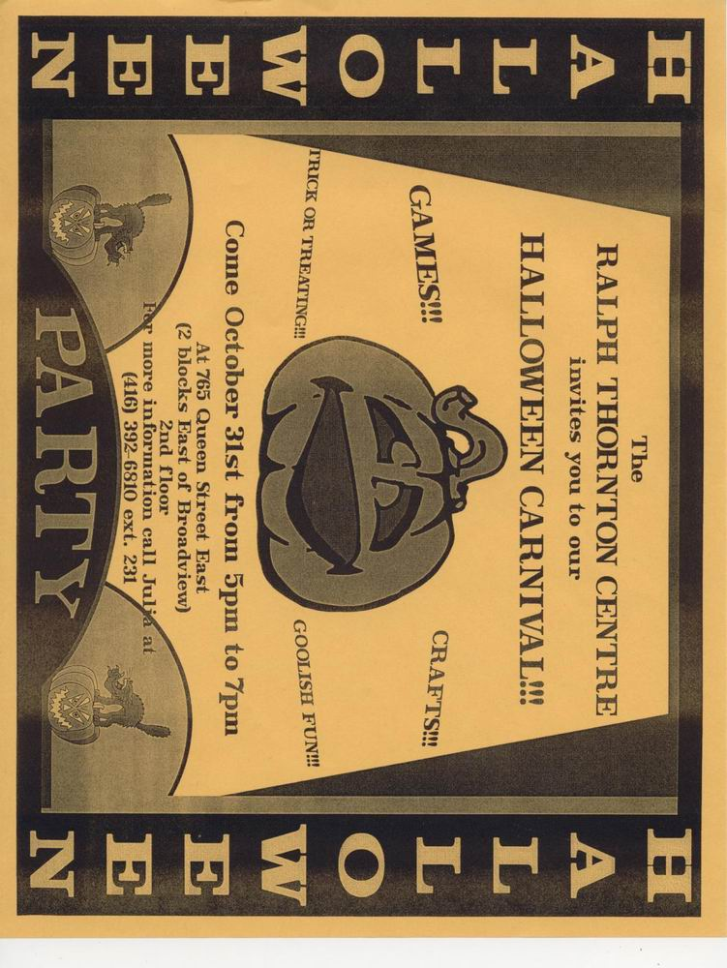

Task Title: Read Everyday Flyers

Task Overview: Individuals receive flyers from stores at Christmas time to let them know about changes in store hours. Answer the following tasks based on the grocery store Holiday Hours.

Holiday Hours

- What is the purpose of this flyer?

- What store is this flyer from? __________________________________

- What dates is the store closed?

- What day is the store opened the latest? ______________________________

- What are the store hours on Dec 31? ____________________________

- Do you feel the store should be closed at 4:00 p.m. on December 31 or stay open later?
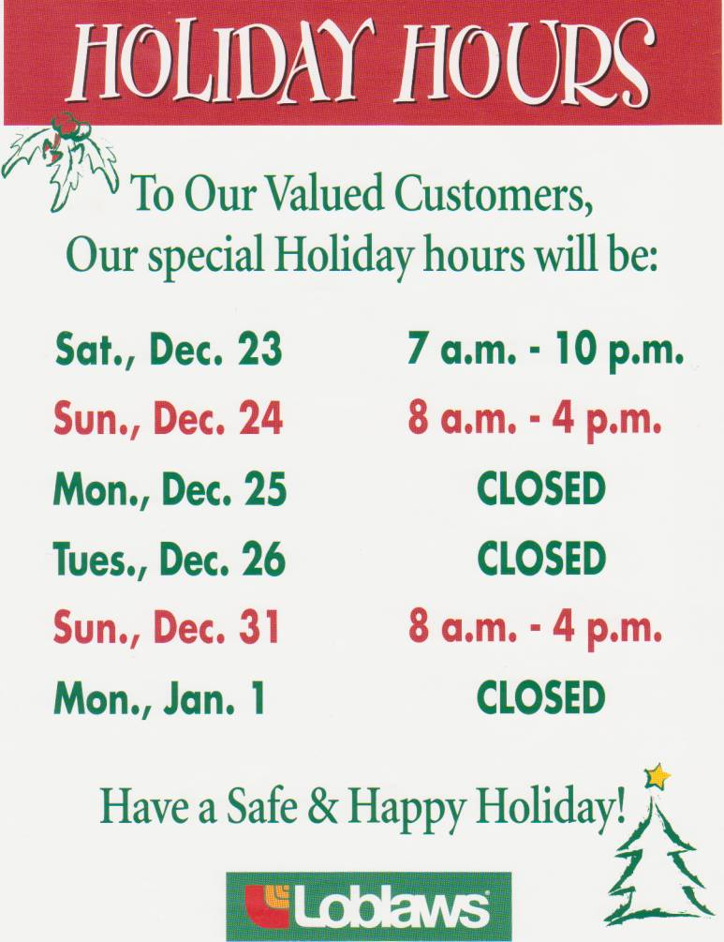

Task Title: Read Everyday Flyers
Task Overview: Individuals receive memos/flyers from schools informing them of events and asking for permission for their child to attend. Answer the following tasks based on the school memo.

School Memo

- What is the purpose of this memo?
- What is the school celebrating?

- Where is the celebration taking place?
- You have a child at the school and agree to let him join the party. Complete the form.
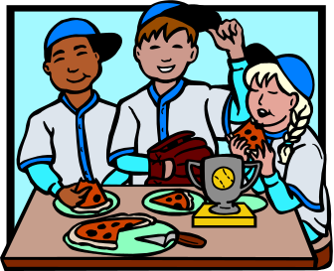
Emery School
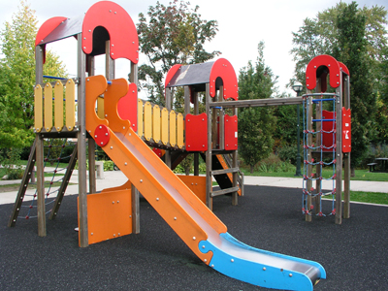
Pizza Party

We are celebrating the opening of our new playground with a pizza party!

When: Wednesday March 21 at 12:00 pm

Where: In the school gym

Who: Students, teachers and parent volunteers

This is a great chance to celebrate all our hard work with students, staff and volunteers.

Please sign below if your child will join us for this celebration.

Student Name: __________________________________________

Phone: _________________________________________

Parent/Guardian Signature: ___________________________________________

Answer Sheet
Halloween Carnival
- What is the purpose of this flyer? To advertise/invite people to attend a Halloween Carnival.
- When is the party? October 31st
- What time is the party being held? 5-7 p.m.
- Where is the party happening? 763 Queen Street East (2 blocks East of Broadview), 2nd floor
- List 2 things that a child can do at this party. Game, Crafts, Trick or Treat (only need 2)
- A number of community centres have parties on Halloween night because they feel it is safer than going door-to-door. Do you feel it is unsafe for children to go door-to-door? Give 2 reasons for your answer. Answers will vary from learner to learner. Make sure they contain 2 reasons.

Holiday Hours
- What is the purpose of this flyer? To tell customers when the store will be open during the Christmas holidays. / To tell customers the Christmas holiday hours for the store (Loblaws).
- What store is this flyer from? Loblaws
- What dates is the store closed? (Mon.) Dec 25, (Tues.) Dec. 26, (Mon.) Jan. 1
- What day is the store opened the latest? Saturday (Dec. 23)
- What are the store hours on Dec. 31? 8 a.m. – 4 p.m.
- Do you feel the store should be closed at 4:00 p.m. on December 31 or stay open later? Answers will vary from learner to learner.

School Memo
- What is the purpose of this memo? To invite students, teachers and parent volunteers to a school pizza party and find out who is coming (collect names of those who plan to attend).
- What is the school celebrating? The opening of its new playground.
- Where is the celebration taking place? The school gym
- You have a child at the school and agree to let him join the party. Kindly provide the child details below. Answers will vary learner to learner. Child’s name, phone number, parent’s name.

Task Title: Read Everyday Flyers
Performance Descriptors |  |  | Needs Work | Completes task with support from practitioner | Completes task independently
Halloween Flyer
A1.1 | - reads short texts to locate a single piece of information
A1.2 | - makes low level inferences
A2.1 | - scans to locate specific details
 | - interprets brief text and common symbols
 | - locates specific details in simple documents, such as labels and signs
B2.1 | - conveys simple ideas and factual information
Store Holiday Hours
A1.1 | - reads short texts to locate a single piece of information
A1.2 | - makes low level inferences
A2.1 | - scans to locate specific details
 | - interprets brief text and common symbols
 | - locates specific details in simple documents, such as labels and signs
B2.1 | - conveys simple ideas and factual information
C2.1 | - recognizes values in number and word format
School Memo
A1.1 | - reads short texts to locate a single piece of information
A2.1 | - scans to locate specific details
 | - interprets brief text and common symbols
 | - locates specific details in simple documents, such as labels and signs
B2.1 | - conveys simple ideas and factual information
B3.1a | - makes a direct match between what is requested and what is entered

This task: was successfully completed___ needs to be tried again___

Learner Comments

____________________________ _________________________

Instructor (print) Learner Signature

