Task-based Activity Cover Sheet
Task Title: Read a Product Brochure
Learner Name:

Date Started: Date Completed:

Successful Completion: Yes___ No___
Goal Path: Employment Apprenticeship___ Secondary School Post Secondary Independence___
Task Description:
Read a brochure to learn about a new product or piece of equipment
Competency:  A: Find and Use Information | Task Group(s):  A1: Read continuous text
Level Indicators:
A1.2: Read texts to locate and connect ideas and information
Performance Descriptors: see chart or click here
Links to skill building activities: see the last page or click here
Materials Required:
- Pen, pencil
- Sample product brochure (attached)
ESKARGO:
- Uses context cues and personal experience to gather meaning from the text
- Scans text to locate simple information
- Uses pictures and illustrations to gather information about the text
- Uses a variety of strategies (patterns of word structure, root words, prefixes and suffixes) to decode and determine the meaning of unfamiliar words
- Draws on personal experience and on reading experience to gather meaning from the text
- Skims to understand type of text
- Reads text having concrete information in familiar, concrete wording; some simple inferential meaning
- Locates multiple pieces of information in familiar text with everyday content and personal and/or general relevance
- Makes connections between sentences and between paragraphs in a single text
- Identifies the topic and purpose of a piece of writing
- Locates multiple pieces of information in simple texts
- Reads more complex texts to locate a single piece of information
- Makes low-level inferences
- Follows the main events of descriptive, narrative, and informational texts
- Obtains information from detailed reading
- Begins to identify sources and evaluate information
- Considers ideas from reading in development of own opinions
- Distinguishes between fact and opinion in text
- Makes judgements (predictions, conclusions) using evidence from the text

Attitudes:
Practitioner,
We encourage you to talk with the learner about attitudes required to complete this task set. The context of the task has to be considered when identifying attitudes. With your learner, please check one of the following:
□ Attitude is not important □ Attitude is somewhat important □ Attitude is very important

Task Title: Read a Product Brochure
Employees are often given new equipment to use on the job. In order to understand a new product, they must read brochures or inserts that explain the benefits of the equipment and how it works.
Look at the brochure from Amstore Innovations about a new product (Digital Key).
Learner Information and Tasks:
Task 1: List 2 things that the Unique ID allows a Digital Key to do.

Task 2: What does the unique ID allow you to track and analyse?

Task 3: What happens when a Digital Key is inserted into a MAC or PC?

Task 4: How does a Digital Key help you understand your client?

Task 5: List the 3 things that the individual ID allows for on each Digital Key for dynamic marketing information.

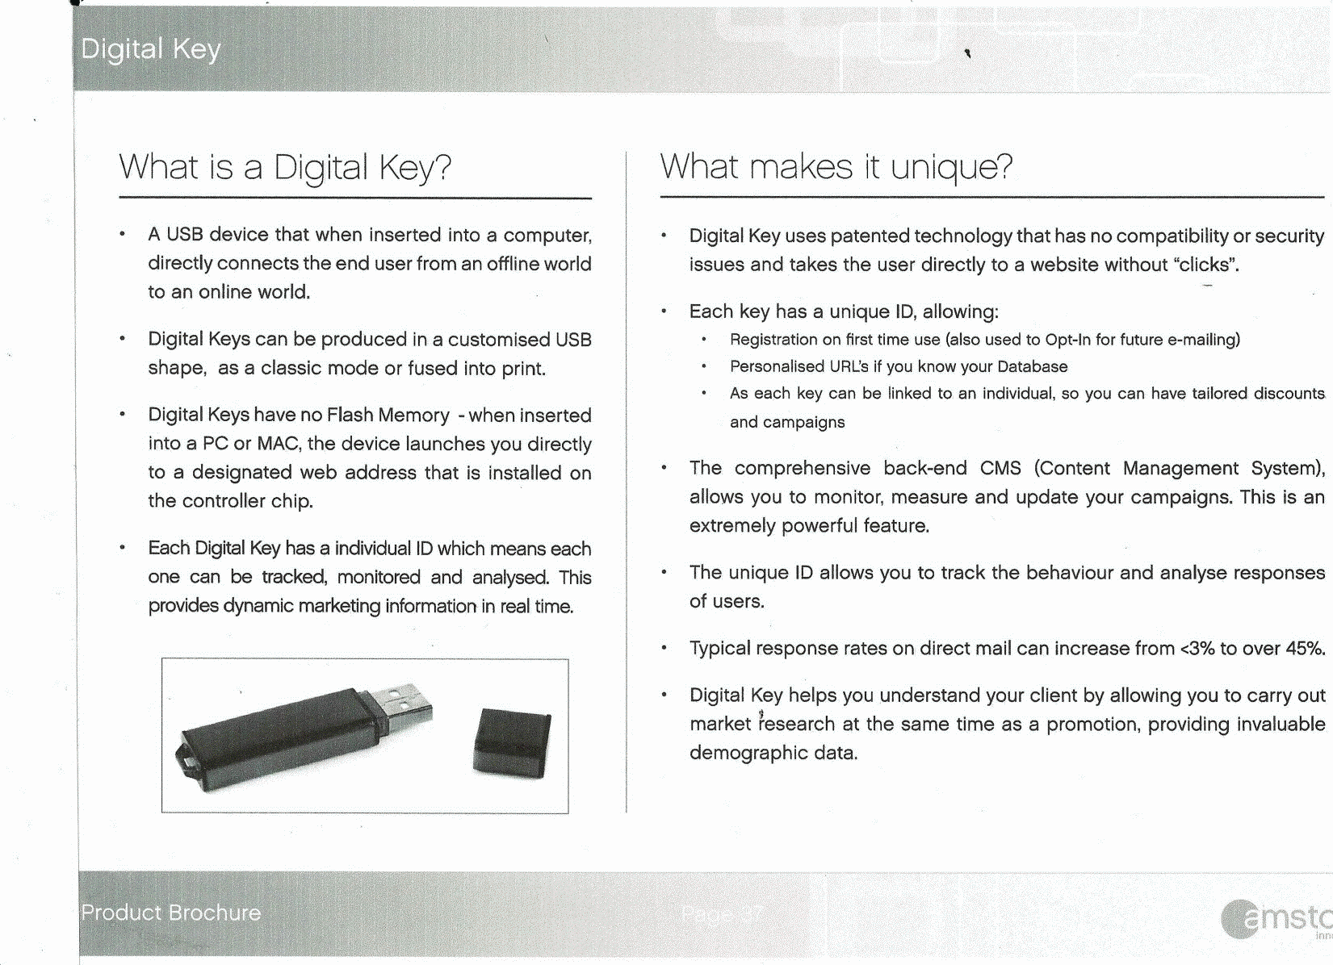
Task Title: Read a Product Brochure
Answer Key
Task 1: List 2 things that the Unique ID allows a Digital Key to do.
Any two of the following:
- Registration on first time use
- Personalized URL’s if you know your Database
- As each key can be linked to an individual, so you can have tailored discounts and campaigns

Task 2: What does the unique ID allow you to track and analyse?
The unique ID allows you to track the behaviour and analyse responses of users

Task 3: What happens when a Digital Key is inserted into a MAC or PC?
The device launches you directly to a designated web address that is installed on the controller chip

Task 4: How does a Digital Key help you understand your client?
By allowing you to carry out market research at the same time as a promotion, providing invaluable demographic data

Task 5: List the 3 things that the individual ID allows for on each Digital Key for dynamic marketing information.
Each one can be tracked, monitored and analysed

Task Title: Read a Product Brochure
Performance Descriptors |  | Needs Work | Completes task with support from practitioner | Completes task independently
A1.2 | - scans text to locate information
 | - locates multiple pieces of information in simple texts
 | - makes low-level inferences
 | - makes connections between sentences and between paragraphs in a single text
 | - begins to identify sources and evaluate information

This task: was successfully completed___ needs to be tried again___

Learner Comments

____________________________ _________________________

Instructor (print) Learner Signature

Skill Building Activities
Links to online resources:
- http://www.ehow.com/how_8195085_read-trifold-brochure.html (A reading activity that describes where to find information on a traditional brochure)
- http://www.bbc.co.uk/skillswise/video/reading-and-understanding (A short video that explains the importance of understanding what you read on the job)
- http://www.wikihow.com/Read-Technical-Writing (A step-by-step guide of how to read technical writing by scanning, using the table of contents and headings, highlighting information and paraphrasing in your own words)
- http://www.howtolearn.com/2013/02/skimming-and-scanning-two-important-strategies-for-speeding-up-your-reading/ (A document that explains how to look for main ideas and important points in text)
- http://www.slideshare.net/AmandaMAllison/reading-techniques-skimming-vs-scanning (A slide show with pointers of how to skim and scan text)

LearningHUB Courses available:

- Reading & Writing, Independent Study
  - Reading Level 2, Assignments 1-3 (Assigned by practitioner after assessment)
- Live classes (SABA):
  - Reading Comprehension; On The Job Thinking Skills
- Independent Study, Short Courses:
  - Improving Your Job Skills; Becoming a Lifelong Learner.

*To access LearningHUB courses, learners must register for the LearningHUB e-Channel program by completing the registration form on their website and completing the course selection (page 2 of the registration form): https://www.learninghub.ca/get_registered.aspx
*To Access LearningHUB Course Catalogue:
http://www.learninghub.ca/Files/PDF-files/HUBcoursecatalogue,%20December%2023,%202014%20revision.pdf

