Task-based Activity Cover Sheet
Task Title: Retail Price of a Coat
Learner Name:

Date Started: Date Completed:

Successful Completion: Yes___ No___
Goal Path: Employment___ Apprenticeship___ Secondary School Post Secondary Independence ✓
Task Description:
Calculate the retail price of a coat, less a store coupon.
Competency:  C: Understand and Use Numbers  A: Find and Use Information | Task Group(s):  C1: Manage Money  A2: Interpret Documents  C2: Manage time
Level Indicators:
C1.1: Compare costs and made simple calculations
A2.1: Interpret very simple documents to locate specific details
C2.1: Measure time and make simple comparisons and calculations

Performance Descriptors: see after answer key or click here
Links to skill building activities: see the last page or click here
Materials Required:
- Flyer of winter coats (attached)
- Pencil
ESKARGO:
C1.1
- Understands place value
- Writes and solves simple addition and subtraction sentences (e.g., 5 + 6 = 11)
- Subtracts whole numbers by borrowing
- Identifies the effect of zero in addition and subtraction
- Adds and subtracts multi-digit whole numbers with and without regrouping
- Identifies and performs required 1-step operations
- Adds and subtracts multi-digit whole numbers and decimals
- Identifies and performs required 1-step operations
Attitudes:
Practitioner,
We encourage you to talk with the learner about attitudes required to complete this task set. The context of the task has to be considered when identifying attitudes.
With your learner, please check one of the following:
___Attitude is not important ___ Attitude is somewhat important ___ Attitude is very important

Task Title: Retail Price of a Coat
Store websites are a good way to shop for items you may need to purchase. Sometimes the online store offers a store coupon. Look at the page from the Sears website.

Learner Information and Tasks:
Task 1: Sears.ca is offering a Customer Appreciation Coupon. What are the dates the coupon can be used?

Task 2: How much money can someone get off the price of the coat if they spend $100 or more?

Task 3: How much money does someone have to spend to get $50 off the price of the coat?

Task 4: Which jacket can qualify for the $20 off coupon?

Task 5: Calculate the cost of the Dockers Tri Blend Stroller Jacket with the discount coupon.

Task 6: Calculate the cost of the Viking Tri-Zone, 3-in-1 Jacket with the discount coupon.

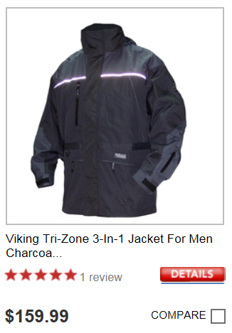


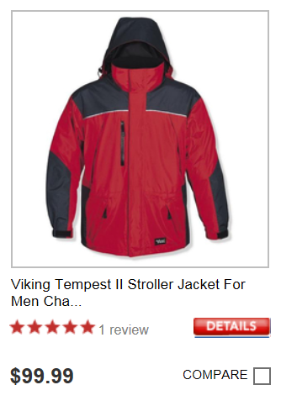
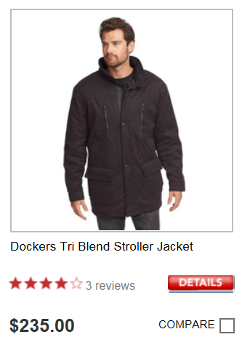


Get $20 OFF
When you spend $100 or more*
On sears.ca or from catalogue

Enter coupon code
941612032
At checkout.
Get $50 OFF
When you spend $200 or more*
On sears.ca or from catalogue

Enter coupon code
941612031
At checkout.

Task Title: Retail Price of a Coat
Answer Key
Task 1: Sears.ca is offering a Customer Appreciation Coupon. What are the dates the coupon can be used?

November 7-12, 2014

Task 2: How much money can someone get off the price of the coat if they spend $100 or more?
$20

Task 3: How much money does someone have to spend to get $50 off the price of the coat?
$200 or more

Task 4: Which jacket can qualify for the $20 off coupon?
Viking Tri-Zone 3-in-1 Jacket

Task 5: Calculate the cost of the Dockers Tri Blend Stroller Jacket with the discount coupon.

$235.00 - 50.00 = $185.00

Task 6: Calculate the cost of the Viking Tri-Zone, 3-in-1 Jacket with the discount coupon.

$159.99 - $20.00 = $139.99

Task Title: Retail Price of a Coat
Performance Descriptors |  | Needs Work | Completes task with support from practitioner | Completes task independently
C1.1 | - adds, subtracts, multiplies and divides whole numbers and decimals
 | - follows apparent steps to reach solutions
 | - interprets and represents costs using monetary symbols and decimals
 | - uses strategies to check accuracy (e.g. estimating, using a calculator, repeating a calculation, using the reverse operation)
A2.1 | - scans to locate specific details
 | - interprets brief text and common symbols
 | - locates specific details in simple documents, such as labels and signs
C2.1 | - understands and uses common date formats

This task: was successfully completed___ needs to be tried again___

Learner Comments

____________________________ _________________________
Instructor (print) Learner Signature
Skill Building Activities
Links to online resources:
How to add, subtract, multiply and divide…:
http://www.mathsisfun.com/numbers/index.html
Scroll down to the “How to add, subtract, multiply and divide…” Each math operation is defined and examples with visuals are used. There are also interactive games and worksheets provided for extra practice.
Adding and Subtracting Decimals:
https://www.khanacademy.org/math/cc-sixth-grade-math/cc-6th-arithmetic-operations/cc-6th-add-sub-decimals
This link brings up several Khan Academy tutorials on adding and subtracting decimals. By using this resource, learners are exposed to a number of examples on how to add decimals, subtract decimals, and decimal word problems.
Multiplying and Dividing Decimals:
http://www.wem.mb.ca/learner_materials.aspx
Scroll down to “K – Multiplying Decimals” and “L – Dividing Decimals.” These tutorials are in two parts: the first video explains the math concept, while the second video shows an example for practice.
Operation Word Clues:
http://www.nwt.literacy.ca/resources/adultlit/problems/contents.htm
By clicking on the “Word Clues” page, learners are given a table with word clues used for addition, subtraction, multiplication and division. Examples of word clues used in word problems are also provided within the table. To view more word clues click on “Next Page” at the bottom of the screen. Learners can also access “Problems with Word Clues” and “Select the Question and Given Information” from the Table of Contents to practice choosing which operation is required.
LearningHUB Courses Available:
Math, Independent Study - 100 Whole Numbers Assignment; 101 Addition, Subtraction Assignment 1 & 2; 201 Multiplication, Division Assignment; 302 Decimals Assignment; 303 Data Analysis Assignment (Assigned by Practitioner after assessment)
Live Classes (SABA) – Multiplication, Division, Decimals A, Decimals B, Math Stories, Making Change
*To access LearningHUB courses, learners must register for the LearningHUB e-Channel program by completing the registration form on their website and completing the course selection (page 2 of the registration form): https://www.learninghub.ca/get_registered.aspx
*To Access LearningHUB Course Catalogue:
http://www.learninghub.ca/Files/PDF-files/HUBcoursecatalogue,%20December%2023,%202014%20revision.pdf

