

Task Title: Review Information on a Job Application

# OALCF Cover Sheet – Practitioner Copy

**Learner Name:___________________________________________**

**Date Started:____________________________________________**

**Date Completed: _________________________________________**

|  |  |  |
| --- | --- | --- |
| **Goal Path:** | Employment | Apprenticeship |
| Secondary School | Post Secondary | Independence |

**Successful Completion:**  Yes No 

**Task Description:** Review a Job Application to locate information.

**Main Competency/Task Group/Level Indicator**

* Find and Use Information/Interpret documents/A2.2

**Materials Required:**

* Pen/pencil and paper and/or digital device

# Learner Information

# When applying for jobs, it is usually necessary to complete an application form.

# Scan “Diversified Transportation Ltd. Application for Employment”.

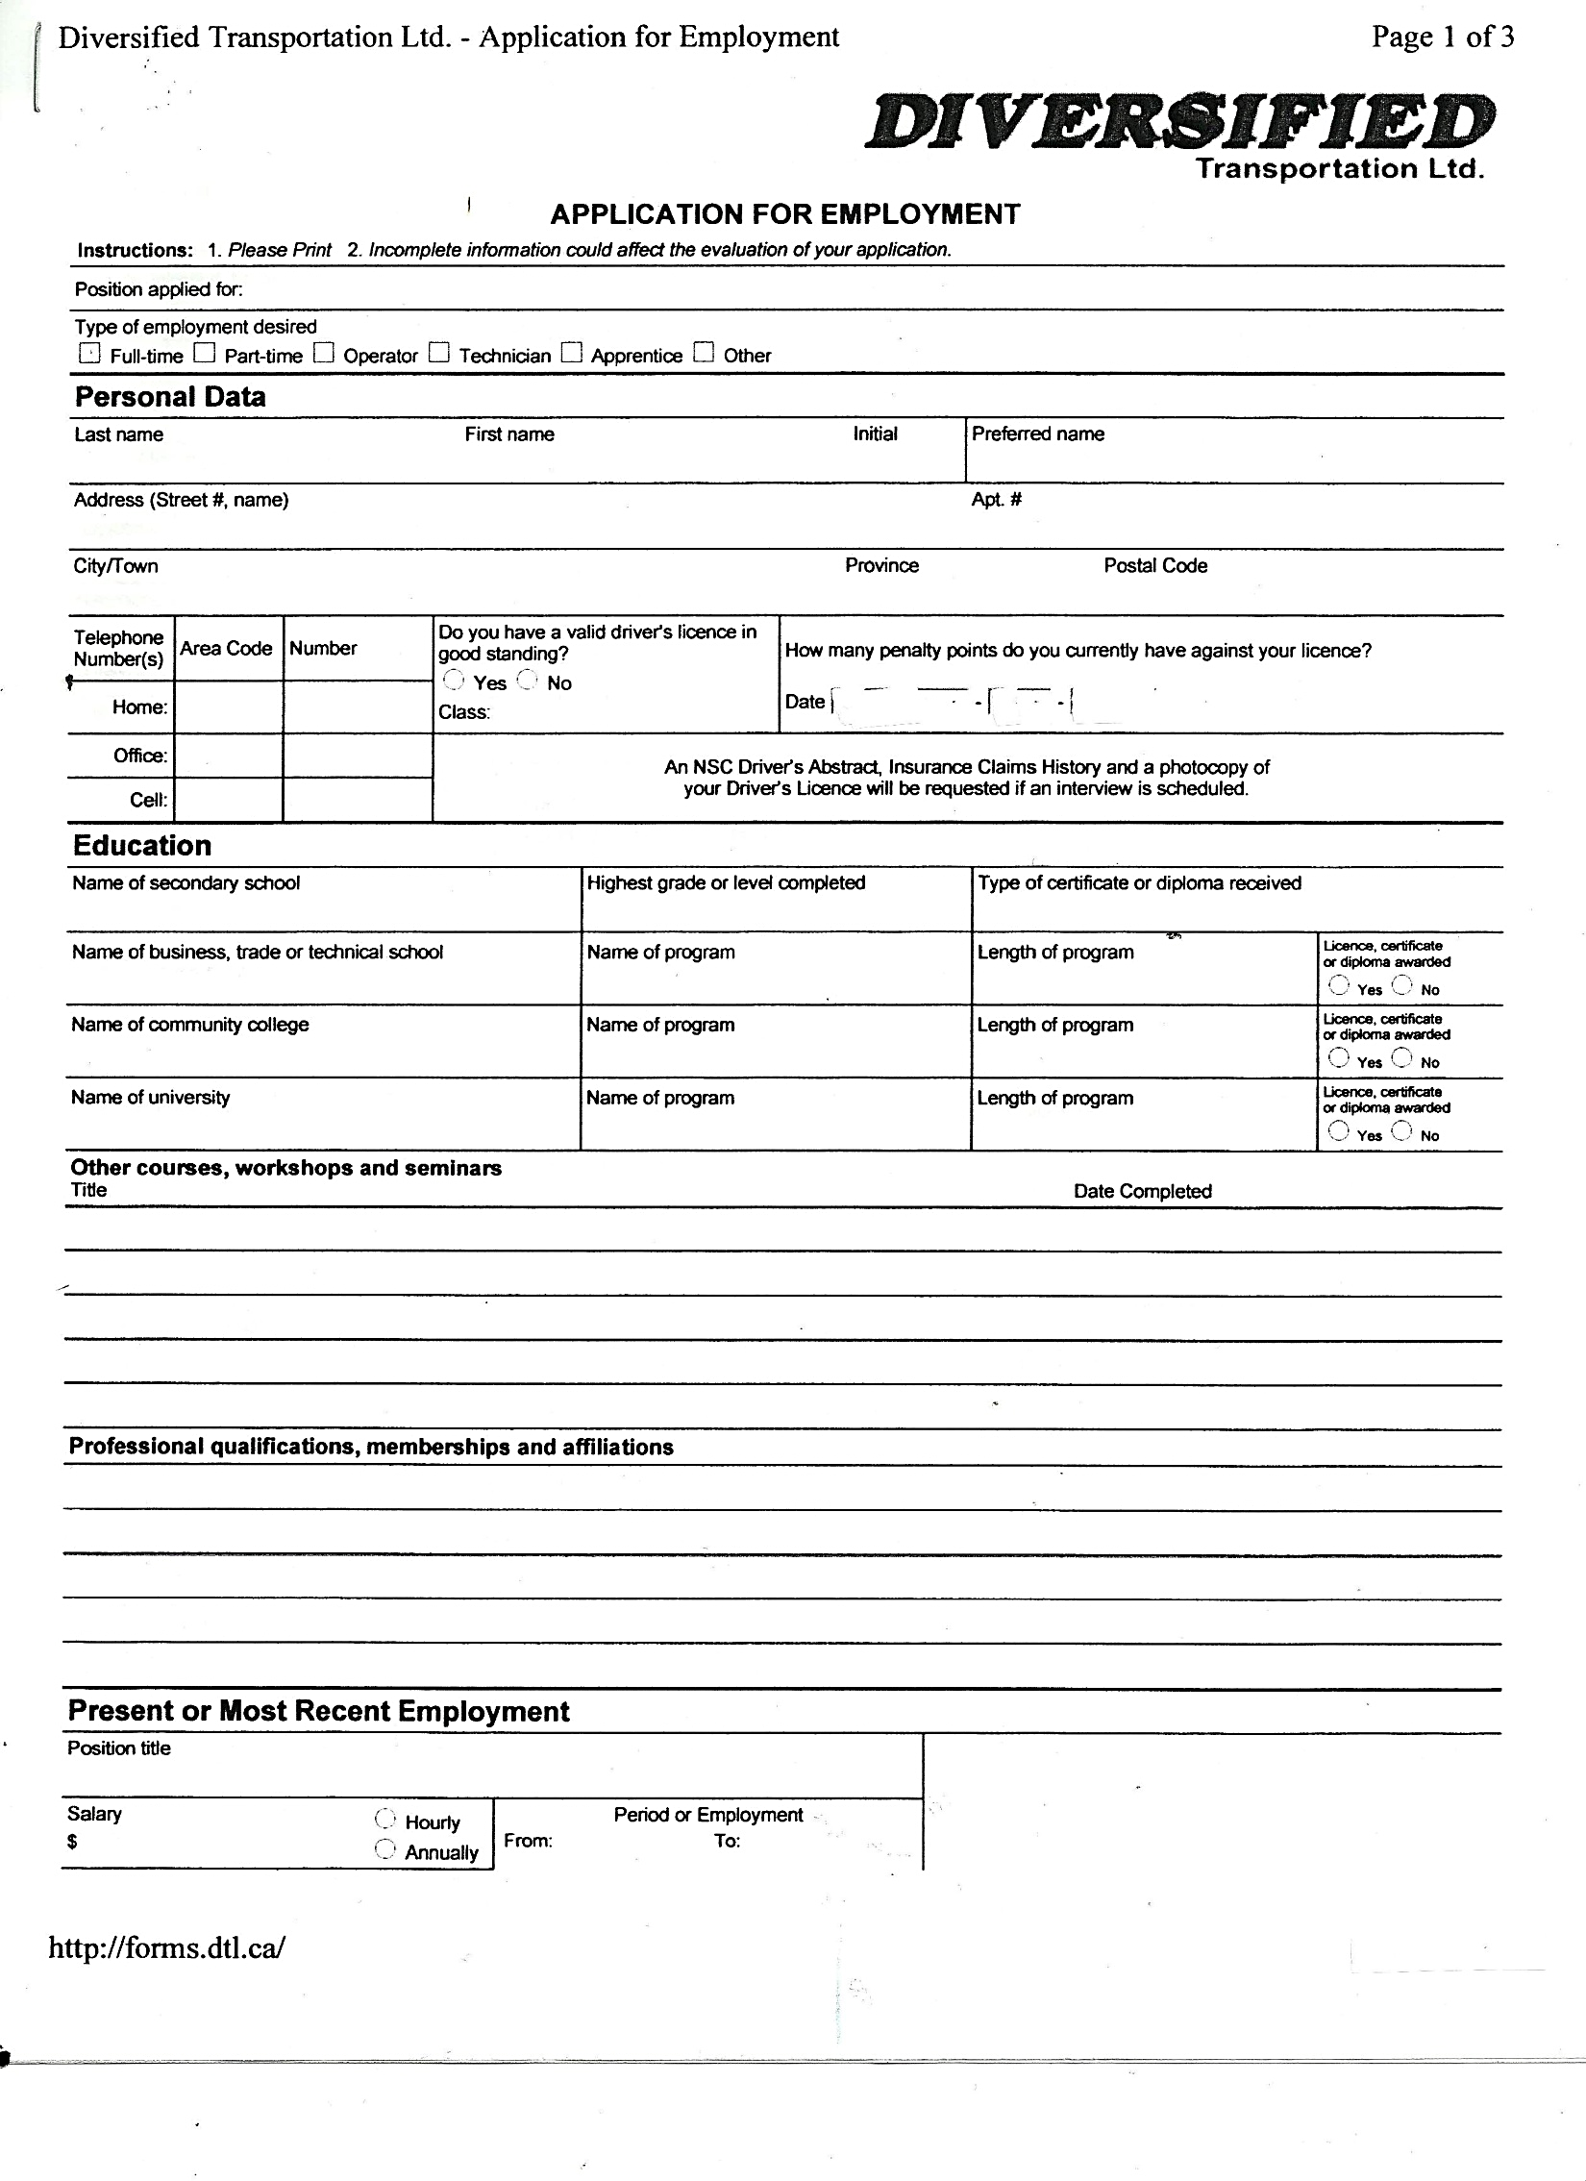

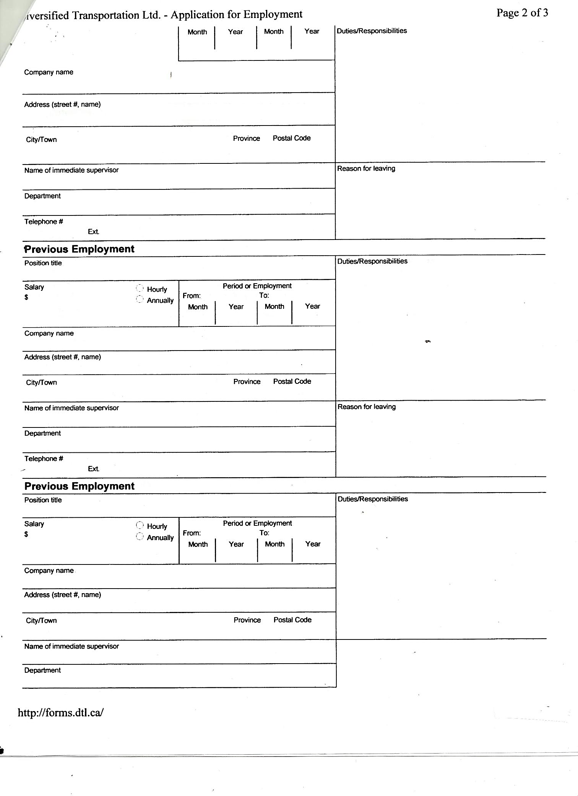

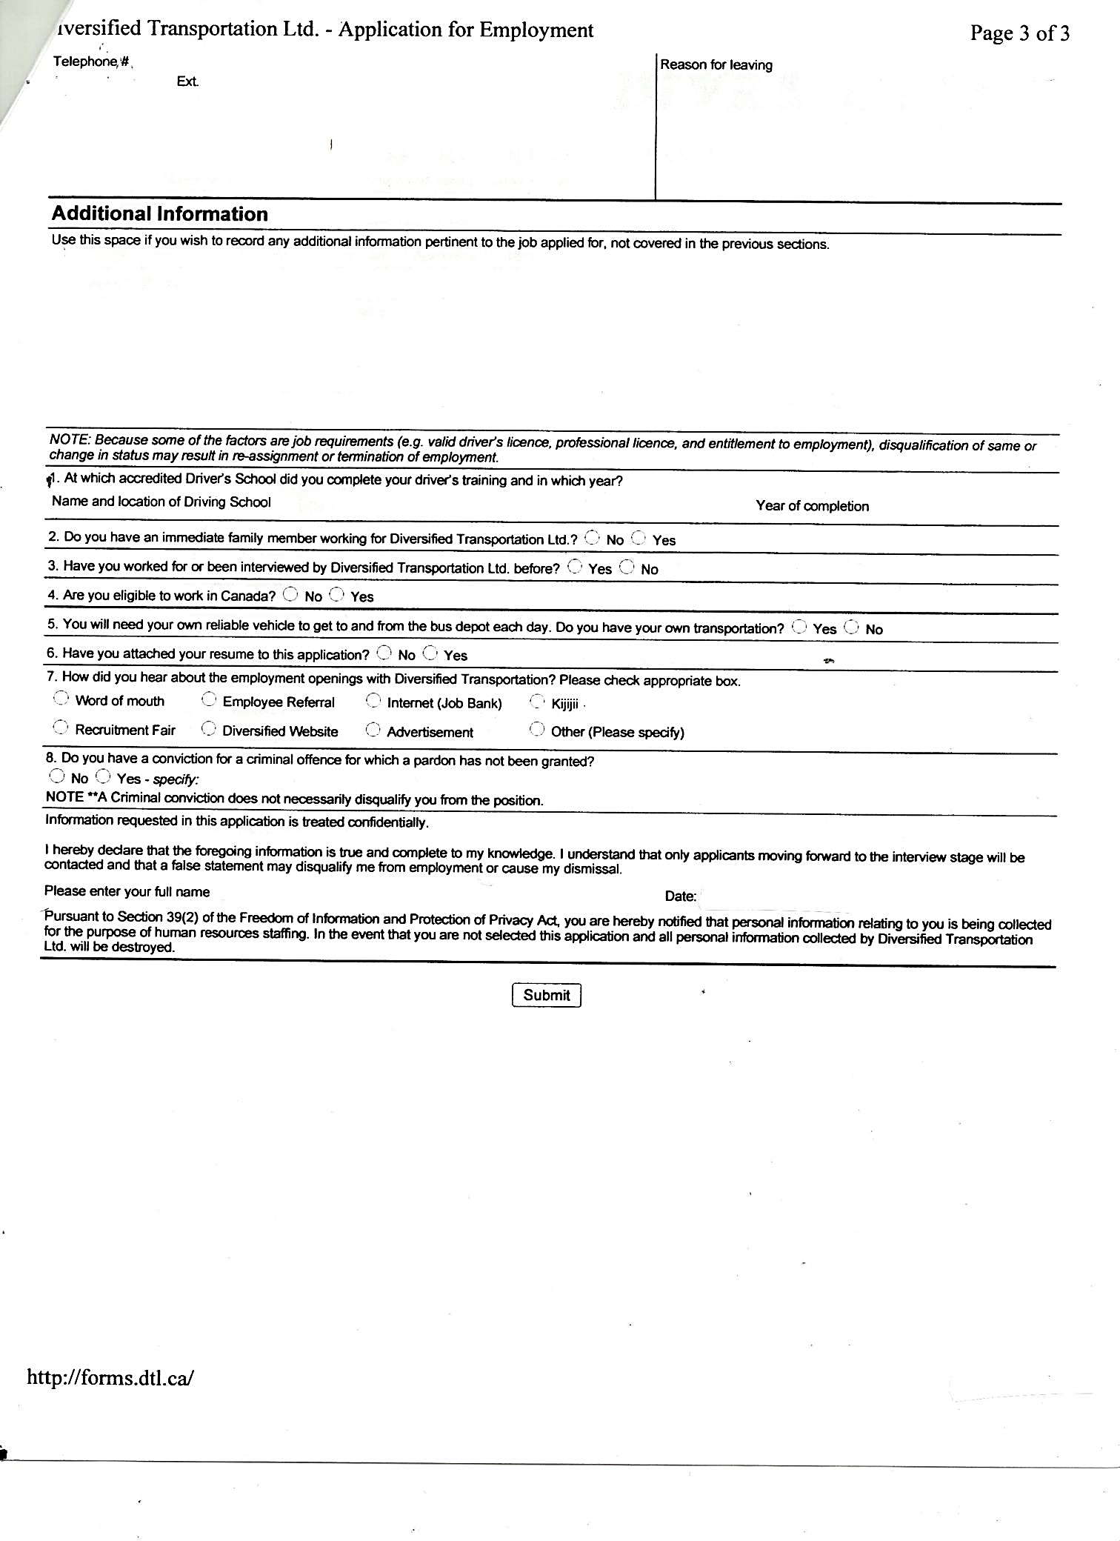

# Work Sheet

**Task 1: What are the two (2) instructions the applicant needs to follow?**

Answer:

**______________________________________________________**

**Task 2: If the applicant has a criminal conviction, what does that mean to the application?**

Answer:

**______________________________________________________**

**Task 3: What three (3) factors are job requirements?**

Answer:

**______________________________________________________**

**Task 4: What three (3) items will the applicant be requested to provide if they are given an interview?**

Answer:

**______________________________________________________**

# Answers

**Task 1: What are the two (2) instructions the applicant needs to follow?**

Answer: Please print and incomplete information could affect the evaluation of your application.

**Task 2: If the applicant has a criminal conviction, what does that mean to the application?**

Answer: A criminal conviction does not necessarily disqualify the applicant from the position.

**Task 3: What three (3) factors are job requirements?**

Answer: Under the “NOTE” on page 3 – valid driver’s license, professional license, entitlement to employment.

**Task 4: What three (3) items will the applicant be requested to provide if they are given an interview?**

Answer: NSC Driver’s Abstract, Insurance Claims History, photocopy of Driver’s License.

# Performance Descriptors

| Levels | Performance Descriptors | Needs Work | Completes task with support from practitioner | Completes task independently |
| --- | --- | --- | --- | --- |
| A2.2 | performs limited searches using one or two search criteria |  |  |  |
|  | extracts information from tables and forms |  |  |  |
|  | uses layout to locate information |  |  |  |
|  | makes connections between parts of documents |  |  |  |
|  | makes low-level inferences |  |  |  |
|  | begins to identify sources and evaluate information |  |  |  |

This task: Was successfully completed Needs to be tried again 

Learner Comments:

Instructor (print): Learner (print):

**_________________ _____________________**