Task-based Activity Cover Sheet
Task Title: Review Information on a Job Application
Learner Name:

Date Started: Date Completed:

Successful Completion: Yes___ No___
Goal Path: Employment Apprenticeship___ Secondary School Post Secondary Independence___
Task Description:
Review a Job Application to locate information
Competency:  A: Find and Use Information | Task Group(s):  A2: Interpret Documents
Level Indicators:
A2.2: Interpret simple documents to locate and connect information
Performance Descriptors: see chart or click here.
Links to skill building activities: see the last pages or click here
Materials Required:
- Pen or pencil
- Job application form (3 pages attached)
ESKARGO:
- Uses knowledge of vocabulary and sight words related to specific forms, tables, graphs, maps and flow charts to obtain meaning
- Uses layout to locate information
- Uses a variety of strategies to decode and determine the meaning of unfamiliar words
- Uses context cues and personal experience to gather meaning from a document
- Scans to locate specific information
- Skims to understand purpose and use of document
- Identifies basic parts of a form, table, simple graph and chart
- Uses understanding of kinds of forms, kinds of tables, kinds of graphs, kinds of maps and kinds of charts to help identify purpose
- Performs limited searches using one or two search criteria
- Locates multiple pieces of information in forms, tables, simple graphs, maps, flow charts
- Makes connections between elements and parts of documents
- Identifies purpose and use of specific forms, tables, simple graphs
- Makes low-level inferences
- Begins to evaluate information

Attitudes:
Practitioner,
We encourage you to talk with the learner about attitudes required to complete this task set. The context of the task has to be considered when identifying attitudes. With your learner, please check one of the following:

□ Attitude is not important □ Attitude is somewhat important □ Attitude is very important

Task Title: Review Information on a Job Application
Learner Information and Tasks:
When applying for jobs, it is usually necessary to complete an application form. Look at the Diversified Transportation Ltd. application for employment.

Task 1: What are the two (2) instructions the applicant needs to follow?

Task 2: If the applicant has a criminal conviction, what does that mean to the application?

Task 3: What three (3) factors are job requirements?

Task 4: What three (3) items will the applicant be requested to provide if they are given an interview?

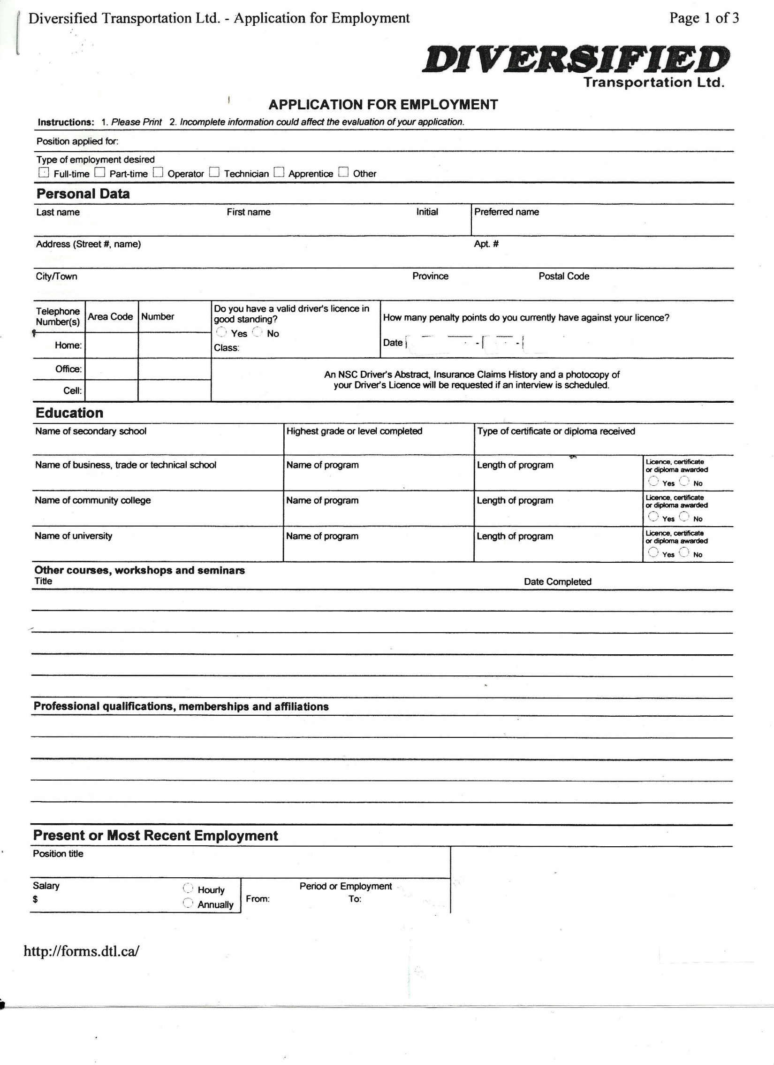

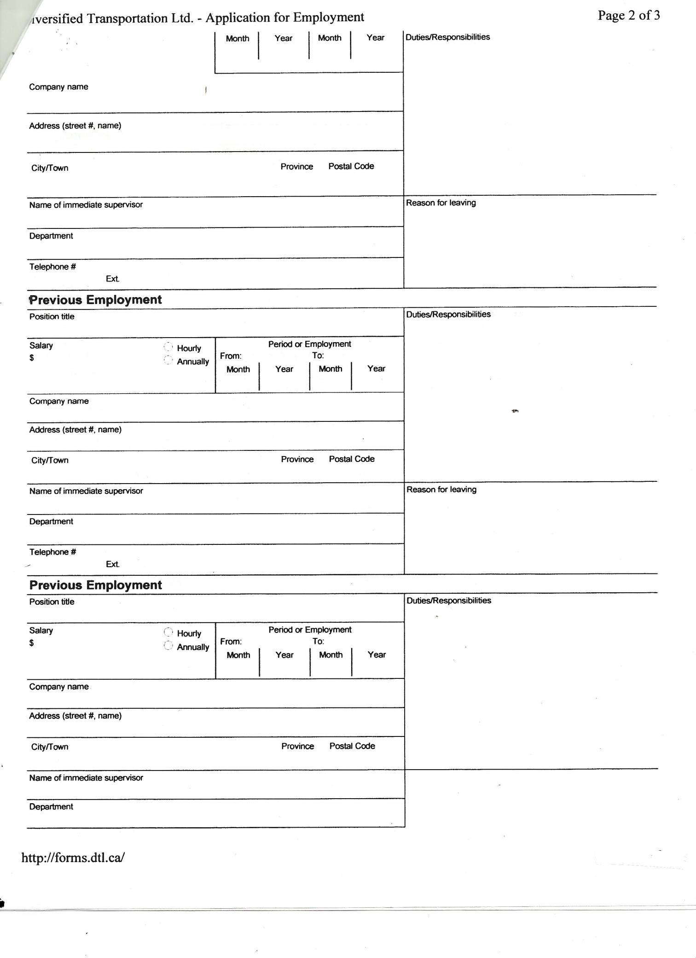

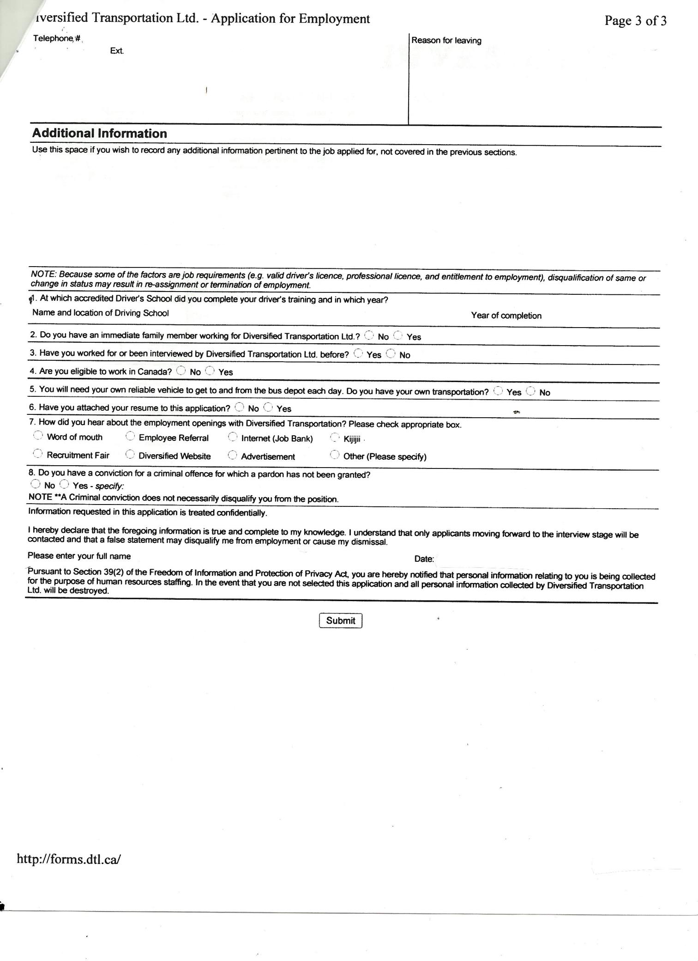

Task Title: Review Information on a Job Application
Answer Key
Task 1: What are the two (2) instructions the applicant needs to follow?
- Please Print
- Incomplete information could affect the evaluation of your application

Task 2: Will a criminal conviction disqualify an applicant from obtaining employment?
A criminal conviction does not necessarily disqualify you from the position

Task 3: What three (3) factors are job requirements?
Under the “NOTE” on page 3 – valid driver’s licence, professional licence, entitlement to employment)

Task 4: What three (3) items will the applicant be requested to provide if they are given an interview?
NSC Driver’s Abstract, Insurance Claims History, photocopy of Driver’s Licence

Task Title: Review Information on a Job Application
Performance Descriptors |  | Needs Work | Completes task with support from practitioner | Completes task independently
A2.2 | - performs limited searches using one or two search criteria
 | - extracts information from tables and forms
 | - uses layout to locate information
 | - makes connections between parts of documents
 | - makes low-level inferences
 | - begins to identify sources and evaluate information

This task: was successfully completed___ needs to be tried again___

Learner Comments

____________________________ _________________________
Instructor (print) Learner Signature

Skill Building Activities
Links to online resources:

Practice Job Applications
http://www.experienceworks.org/site/PageServer?pagename=Practice_Online_application
http://www.gcflearnfree.org/edlall/job-application
Finding Unfamiliar Words
www.dictionary.com
Job Application Guide
http://jobsearch.about.com/od/jobapplications/a/jobapplicationguide.htm

LearningHUB online courses available:
- Reading & Writing, Independent Study (assigned by practitioner following assessment)
  - PLATO Reading Level 2; Basic Skills for the Real World
- Essential Skills, Independent Study (assigned by practitioner following assessment)
  - Job Skills for the Real World
- Essential Skills, Independent Study Short Courses (assigned by practitioner following assessment)
  - Improving Your Job Skills
- Live Classes (SABA) – Filling in Forms; On the Job Thinking Skills

*To access LearningHUB courses, learners must register for the LearningHUB e-Channel program by completing the registration form on their website and completing the course selection (page 2 of the registration form): https://www.learninghub.ca/get_registered.aspx
*To Access LearningHUB Course Catalogue:
http://www.learninghub.ca/Files/PDF-files/HUBcoursecatalogue,%20December%2023,%202014%20revision.pdf

