OALCF Task Cover Sheet
Task Title: Searching the Job Bank
Learner Name:

Date Started: Date Completed:

Successful Completion: Yes___ No___
Goal Path: Employment ✓ Apprenticeship___ Secondary School Post-Secondary Independence___
Task Description:
Learners will do tasks related to a job posting on Canada’s Job Bank
Competency:  A: Find and Use Information | Task Group(s):  A2: Interpret Documents
Level Indicators:
A2.1: Interpret very simple documents to locate specific details

Performance Descriptors: see chart on last page
Skill Building Activity: Please find skill building activities at the end of this task set or click here.
Materials Required:
- Learner information sheet
- “Job Posting” document
- Pencil or pen

Task Title: Searching the Job Bank
Individuals use the Canada Job Bank to search for potential jobs. Look at the Job Posting for the Sales and Customer Service Agent.
Learner Information and Tasks:
Task 1: How much is the hourly wage or for the Customer Service Agent?

Task 2: What is the Job Number for the Customer Service Agent?

Task 3: When is the anticipated start date for the Customer Service Agent?

Task 4: What are the terms of employment?

Task 5: How many positions are available?

Task 6: Who is the employer?

Task 7: What education is required for the position?

Task 8: What experience is required for the position?

Task 9: What specific skills are required for the job?

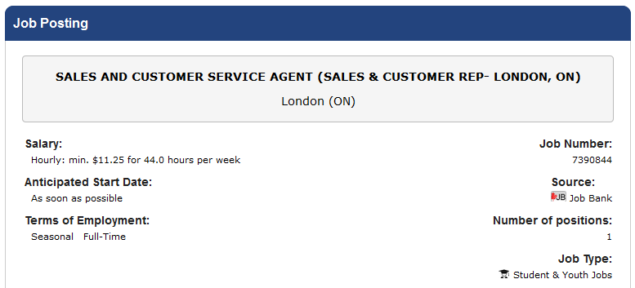
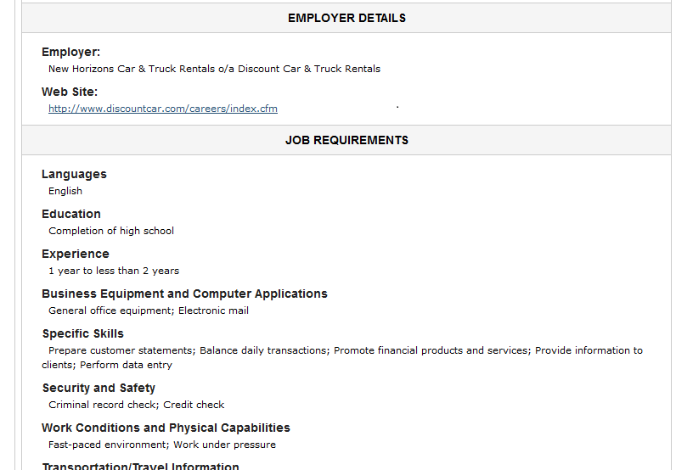

Task Title: Searching the Job Bank
Answer Key
Task 1: $11.25
Task 2: 7390844
Task 3: As soon as possible
Task 4: Seasonal, full-time
Task 5: 1
Task 6: New Horizons Car & Truck Rentals
Task 7: Completion of high school
Task 8: 1 year to less than 2 years
Task 9: Prepare customer statements; Balance daily transactions; Promote financial products and services; Provide information to clients; Perform data entry

Task Title: Searching the Job Bank
Performance Descriptors |  | Needs Work | Completes task with support from practitioner | Completes task independently
A2.1 | - scans to locate specific details
 | - interprets brief text and common symbols
 | - locates specific details in simple documents, such as labels and signs

This task: was successfully completed___ needs to be tried again___

Learner Comments

____________________________ _________________________

Instructor (print) Learner Signature
Skill Building Activity: Searching the Job Bank
Practitioner Notes

Though this activity would primarily benefit those learners on an employment goal path it could easily be applicable across the various goal paths, especially in a diverse classroom. The activity functions as a high level digital competency task that lends itself well to training learners to utilize other digital search based applications.

It is strongly urged that this skill building activity be printed out to help guide the learner through this complex lesson. It would be best to print off the activity in colour as visual cues have been added to increase understanding and help manage the distracters.

A precursor class regarding resume building and cover letter best practices may also be beneficial not only to the learner’s success with this activity, but in their acquisition of employment as well. If you expect the learners to apply for jobs during the activity, then ensure that prior to beginning this activity a resume and cover letter are worked on, or brought in (digital copies). Additionally, learners should have a professional email account on hand to utilize for applying to jobs, corresponding, etc.

The practitioner should modify the activity and provide scaffolding where necessary.
It is important to note that internet pages are fickle and that browsers will look and operate slightly differently, keep this in mind when aiding your learners. It would be best to personally undertake the activity beforehand to ensure that the Job Bank website has not been altered.

This activity is not exhaustive – encourage learners to explore other sections of the website as many other tools are available. This may require supervision if learners get lost on the website as it is rich with distracters.

Skill Building Activity: Searching the Job Bank

Loading the Job Bank Website

Go to the Job Bank by typing in the following search term, "Job Bank," into the Google search engine (www.google.ca).

- You will be looking for Job Bank: Home in the search results.

- Click on Job Bank: Home to load the Job Bank website:

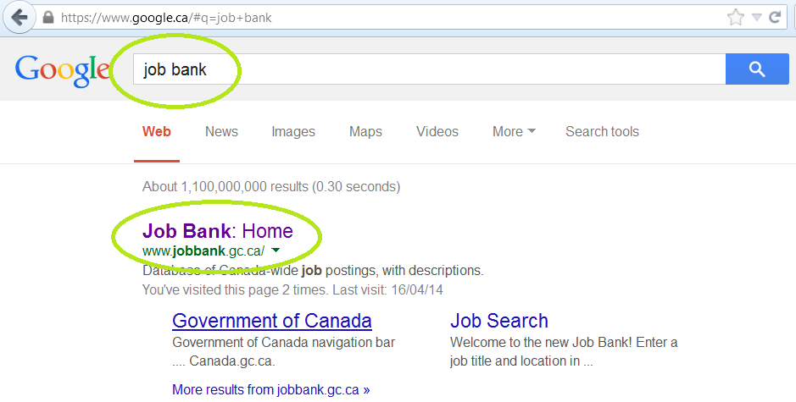

Or, you can get to the Job Bank directly by typing the following website address into the address bar of your browser:

http://www.jobbank.gc.ca


Skill Building Activity: Searching the Job Bank

Perform a Job Search

- In the search field labelled Job and/or Location type in words that describe the kind of job you are looking for (ex. "retail," "labourer," "delivery driver" ) as well as the region you would like to work in (ex. "London, Ontario").

- Use broad terms such as "customer service," "administration," etc. You will be able to narrow down your search later.

- Click on Search and wait for the results of your job search to load.

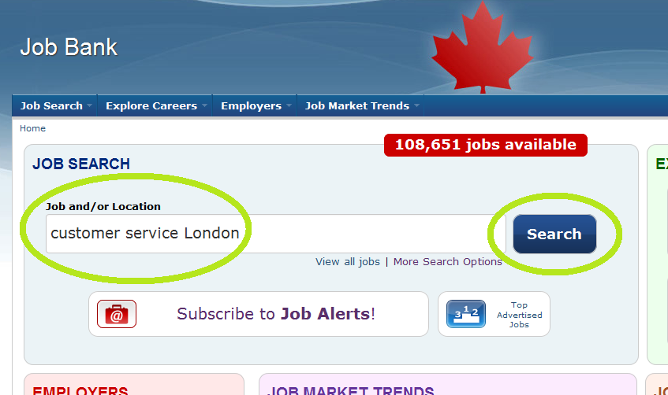

Separating phrases with commas tells the search engine to group those words together. For example: "customer service , London"

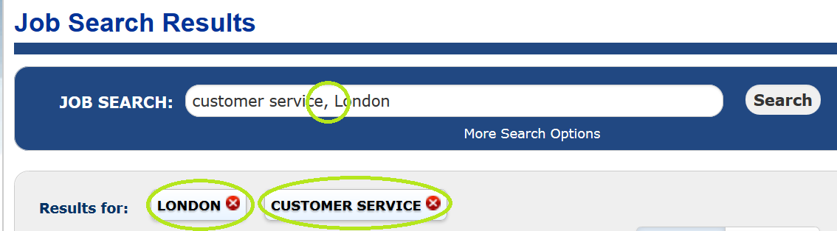
Skill Building Activity: Searching the Job Bank

Narrow Your Search with Filters

There is a lot of content on the internet. Search engines need a little help to find exactly what you are looking for. “Filters” are parameters or criteria that a search engine uses to narrow down your search results. You can add or remove filters at any time to narrow or broaden your results.

After the results of your initial job search load you can then sort the results by selecting either the Best Match or Date Posted filters:

The Best Match filter will search the bank for job postings that are the closest match to what you originally searched for. (This will be selected by default).

The Date Posted filter will display the job postings in chronological order starting from the most recently posted job.

Click out both filters to get a feel for how they work.

At any time you can click on More Search Options located underneath the Job and/or Location search field to bring up a larger list. These filters will make your searches more specific and narrow down the results.

*At any time you can click on the white Job Bank title at the top left of the page to restart your job search from the home screen.

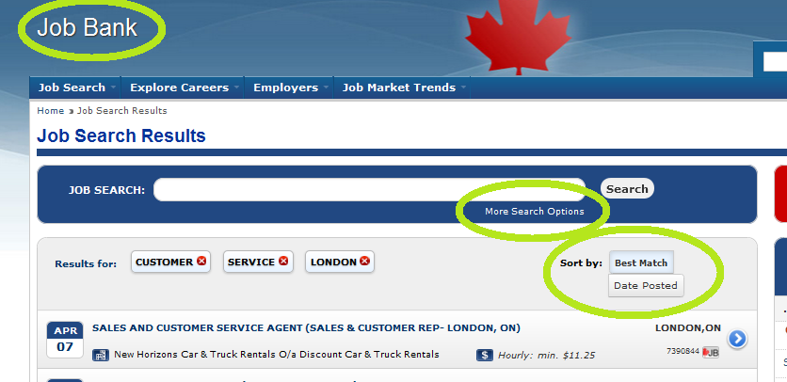

Skill Building Activity: Searching the Job Bank

You can determine how many job postings were found by looking at the big red box on the top right of the screen under Jobs Found. You can also narrow down your search by clicking on the red filters located down the right side of the page underneath Jobs Found. Watch the total number of jobs in the red Jobs Found box to see how adding or removing filters affects the number of jobs found.

Click on some of these filters to get a feel for how they narrow your search results:

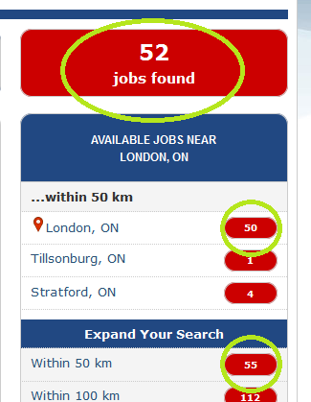

Broaden Your Search by Deselecting Filters

If only a few job postings were found for your search then you can broaden the search by deselecting one or more of the filters or search terms. For example, if you click on the red X’s beside your search terms they will be removed (deselected) and the number of search results will increase. This is because you are asking the job search engine to be less specific when searching for jobs.

Click on the red X beside the location you entered to broaden your search results:



This will remove the location filter that you originally searched under. Now the Job Bank will only search for job titles and descriptions. It will pay less attention to the location of the types of jobs that you are searching for. You can remove any search filter in the same way to broaden your search.

Skill Building Activity: Searching the Job Bank

Understanding the Initial Search Results

- Date the job was posted.

- Company name or placement agency name.

- Job position or title.

- Hourly wage or salary.

- Location of the job position.

- Job Number.

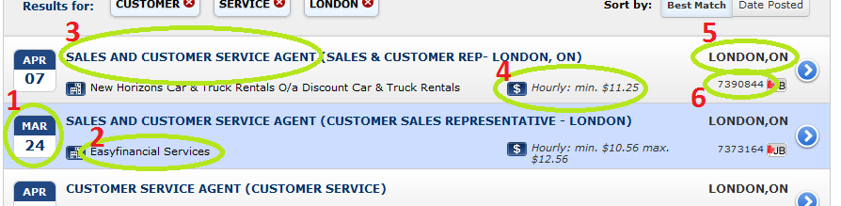

The Job Number is important to write down if you are interested in a specific job that you have found. If you happen to close your browser or lose track of the specific job that you were interested in - this number will allow you to find it later on. Simply type that number into the search bar and click on Search to find the specific job again.

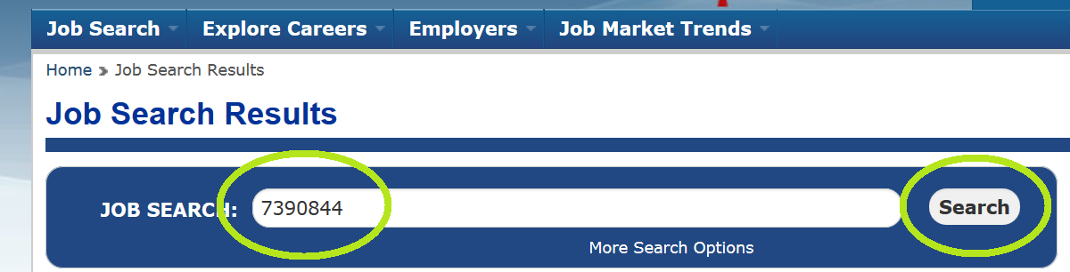

Skill Building Activity: Searching the Job Bank

Job Posting Details

Click on a job posting that you are interested in exploring further. The page that opens will give you a much more detailed understanding of the Employer Details and Job Requirements.

Skill Building Activity: Searching the Job Bank

Search for three (3) different jobs in your region that you are interested in. Use complete sentences to answer the following questions:

Which job are you best suited for out of the three that you researched? Why?

List some changes that you can make to your resume and cover letter to increase your chances of getting this specific job:

