OALCF Task Cover Sheet
Task Title: Understand Temperature in Celsius and Fahrenheit
Learner Name:

Date Started: Date Completed:

Successful Completion: Yes___ No___
Goal Path: Employment___ Apprenticeship___ Secondary School___ Post Secondary___ Independence √
Task Description:
Learners on the Independence Path will need to understand the differences in temperature for planning daily activities including what is appropriate clothing.
Competency:  A: Find and Use Information  B: Communicate Ideas and Information  C: Understand and Use Numbers | Task Group(s):  A1: Read continuous text  A2: Interpret documents  B3: Complete and create documents  C3: Use measures
Level Indicators:
A1.1: Read brief texts to locate specific details
A2.1: Interpret very simple documents to locate specific details
A2.2: Interpret simple documents to locate and connect information
B3.1: Make straightforward entries to complete very simple documents
C3.1: Measure and make simple comparisons and calculations
Performance Descriptors: see chart on last page
Materials Required:
- Attached sheet
- Pen

Task Title: Understand Temperature in Celsius and Fahrenheit
Learner Information and Tasks:
Complete the following questions using the thermometers below
- In the month of June the temperature is 20°. Is that temperature in Celsius or Fahrenheit?

- Write out in numbers the temperatures for
  - thirty degrees Fahrenheit ____
  - eighteen degrees Celsius_____.

- What type of clothes would you wear outside for the temperatures in question 2?
- On the Celsius scale, all temperatures below 0 are written with a minus sign (-). Is it the same for the Fahrenheit scale?

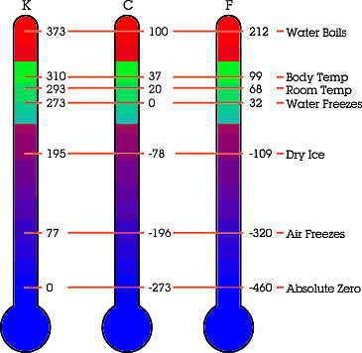

Task Title: Understand Temperature in Celsius and Fahrenheit
Performance Descriptors |  | Needs Work | Completes task with support from practitioner | Completes task independently
A1.1 | - Follows simple, straightforward instructional texts
A2.1 | - Scans to locate specific details
 | - Interprets brief text and common symbols
A2.2 | - Uses layout to locate information
 | - Makes connections between parts of documents
 | - Makes low level inference
B3.1 | - Makes entries using familiar vocabulary
C3.1 | - recognizes values in number and word format
 | - uses common measuring tools, such as rulers, scales and thermometers
 | - understands numerical order
 | - begins to interpret integers (e.g. temperature, elevation)
This task: was successfully completed___ needs to be tried again___

Learner Comments

____________________________ _________________________

Instructor (print) Learner Signature

