Task-based Activity Cover Sheet
Task Title: Interpret an Academic Timetable
Learner Name:

Date Started: Date Completed:

Successful Completion: Yes___ No___
Goal Path: Employment___ Apprenticeship Secondary School Post Secondary Independence___
Task Description:
Find class times and locations of classrooms on an academic timetable
Competency:  A: Find and Use Information | Task Group(s):  A2: Interpret Documents
Level Indicators:
A2.2: Interpret simple documents to locate and connect information
Performance Descriptors: see chart or click here.
Links to skill building activities: see the last pages or click here
Materials Required:
- Pen, pencil
- Sample course timetable (attached)
ESKARGO:
- Uses layout to locate information
- Scans to locate specific information
- Reads times, dates, codes
- Performs limited searches using one or two search criteria
- Locates multiple pieces of information in forms, tables, simple graphs, maps, flow charts
- Identifies timing of events
- Makes low-level inferences
- Begins to evaluate information
Attitudes:
Practitioner,
We encourage you to talk with the learner about attitudes required to complete this task set. The context of the task has to be considered when identifying attitudes. With your learner, please check one of the following:
□ Attitude is not important □ Attitude is somewhat important □ Attitude is very important

Task Title: Interpret an Academic Timetable
Many schools provide students with a course timetable each semester. Timetables tell students when and where their classes will be held. At some schools, students are responsible for choosing their course sections, so being able to accurately read a timetable will help them create a schedule and prevent them from choosing courses that overlap. Look at the Student Timetable.
Learner Information and Tasks:

Task 1: How many Semesters are there in the school year?

Task 2: What time would a student finish on Day 1 in Semester 2?

Task 3: What time does SNC1WL-A start on Day 4?

Task 4: Which room number is the SNC1WL-A class located?

Task 5: Which Semester and day on the schedule do classes begin after 9:00am?

Task 6: How many different courses are included in this Student Timetable?

Task Title: Interpret an Academic Timetable

Task 7: A student wants to take a Spanish course. Spanish courses are always offered in the third period on day 2. In which semester does the student have room in their schedule to take this course?

Task 8: What course is the student taking in Semester Two, Day 3, period 4?

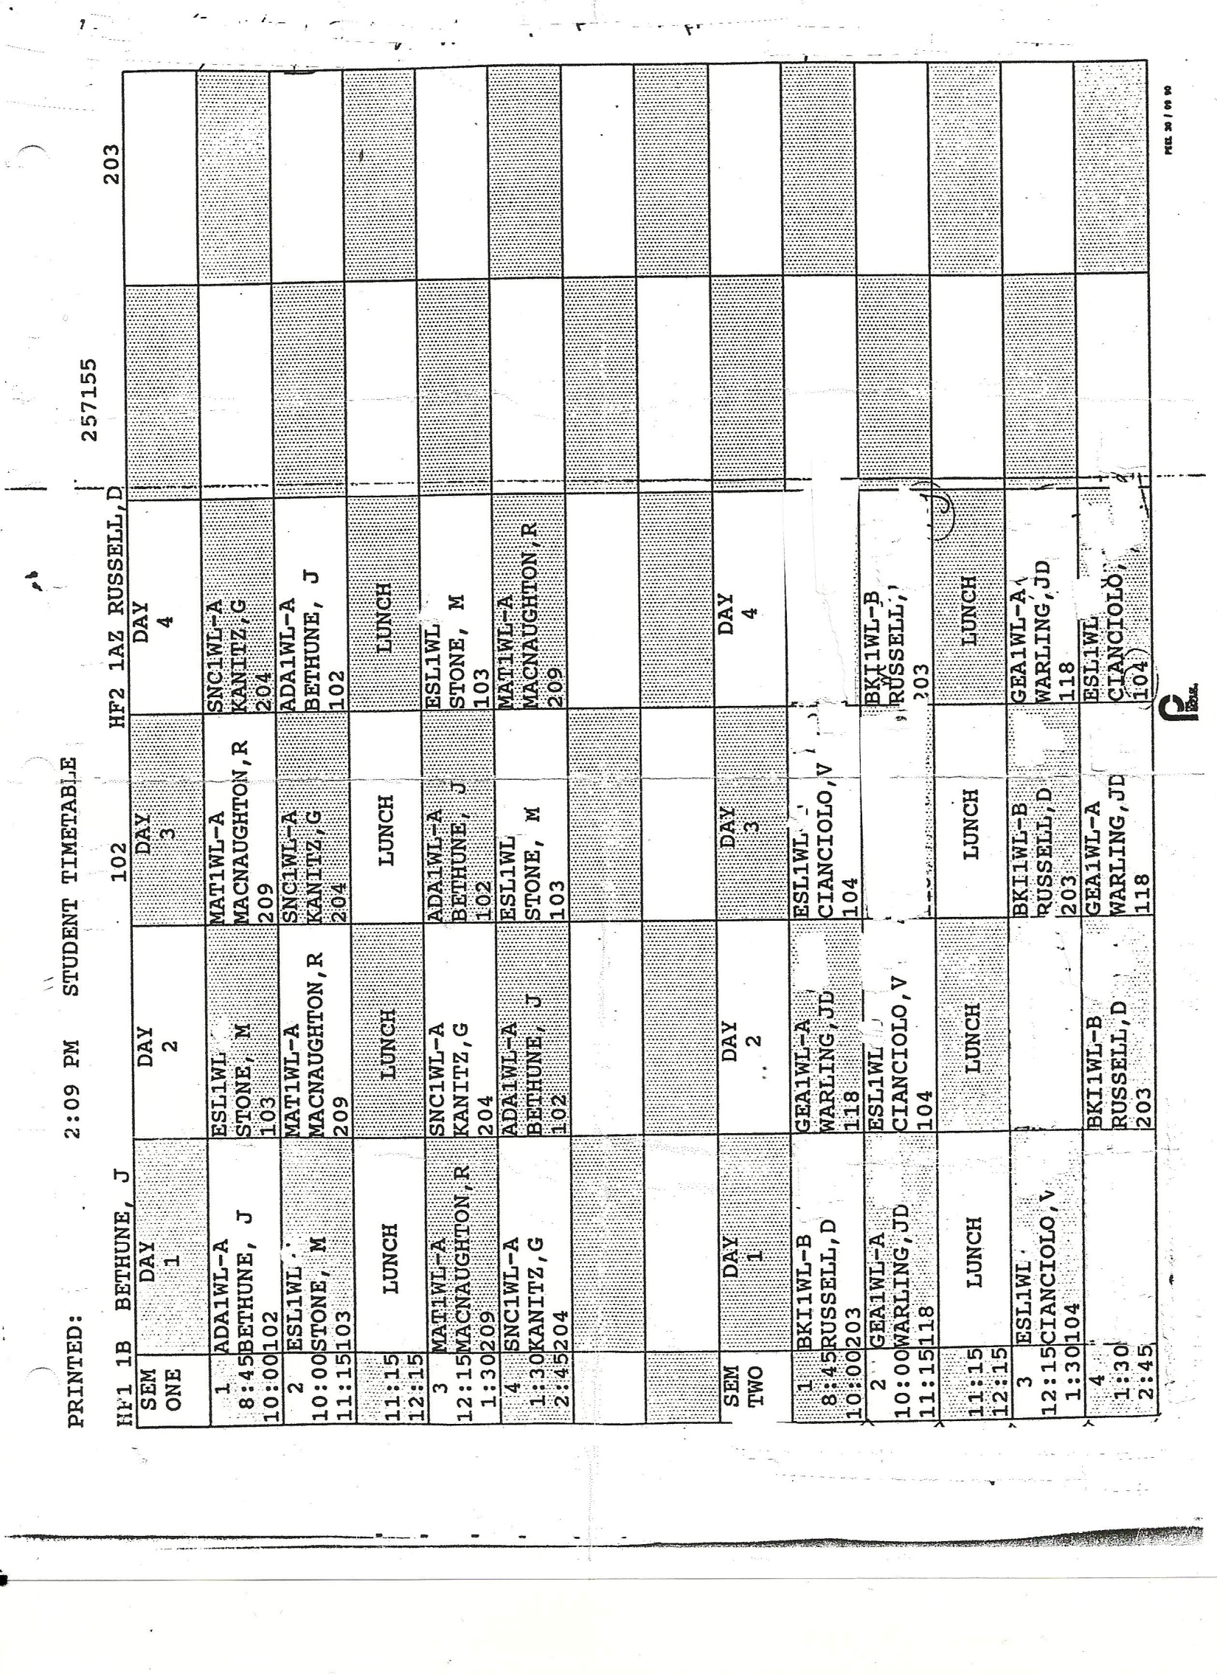

Task Title: Interpret an Academic Timetable
Answer Key
Task 1: How many semesters are there in this school year?
Two semesters
Task 2: What time do you finish on Day 1 Semester 2?
1:30pm
Task 3: What time do you begin SNC1WL-A on Day 4?
8:45am
Task 4: Which room number is the SNC1WL-A class located?
Room 204
Task 5: What day(s) on this schedule do you begin after 9:00am?
Semester 2 Day 4
Task 6: How many different courses are included in this Student Timetable?
6 total courses – ADA1WL, ESL1WL (in both semesters), MAT1WL, SNC1WL, BKI1WL, GEA1WL
Task 7: You want to take a Spanish course. Spanish courses are always offered in third period on day 2. In which semester do you have room in your schedule to take this course?
Semester 2
Task 8: What course is the student taking in Semester Two, Day 3, period 4?
GEA1WL-A

Task Title: Interpret an Academic Timetable
Performance Descriptors |  | Needs Work | Completes task with support from practitioner | Completes task independently
A2.2 | - performs limited searches using one or two search criteria
 | - extracts information from tables and forms
 | - locates information in simple graphs and maps
 | - uses layout to locate information
 | - makes connections between parts of documents
 | - makes low-level inferences
 | - begins to identify sources and evaluate information

This task: was successfully completed___ needs to be tried again___

Learner Comments

____________________________ _________________________
Instructor (print) Learner Signature

Skill Building Activities
Links to online resources:

Practice Reading Time Tables
TRAIN: http://learnenglishteens.britishcouncil.org/skills/reading-skills-practice/train-timetable
PRINTABLE WORKSHEETS: http://www.dr-mikes-math-games-for-kids.com/support-files/timetable-worksheets.pdf

Reading & Interpreting Data
https://www.khanacademy.org/search?page_search_query=charts

LearningHUB online courses available:
- Essential Skills, Independent Study (assigned by practitioner following assessment)
  - Document Use
  - Reading Level 1 & 2
- Reading & Writing, Independent Study (assigned by practitioner following assessment)
  - Basic Skills for the Real World
- Live Classes (SABA) - Filling in Forms

*To access LearningHUB courses, learners must register for the LearningHUB e-Channel program by completing the registration form on their website and completing the course selection (page 2 of the registration form): https://www.learninghub.ca/get_registered.aspx
*To Access LearningHUB Course Catalogue:
http://www.learninghub.ca/Files/PDF-files/HUBcoursecatalogue,%20December%2023,%202014%20revision.pdf

