

Task Title: WHMIS Pictograms

# OALCF Cover Sheet – Practitioner Copy

**Learner Name:**

**Date Started:**

**Date Completed:**

|  |  |  |
| --- | --- | --- |
| **Goal Path:** | Employment | Apprenticeship |
| Secondary School | Post Secondary | Independence |

**Successful Completion:**  Yes No

**Task Description:**

Use the WHMIS Pictograms Infographic to answer questions about the symbols identifying hazardous materials.

**Main Competency/Task Group/Level Indicator:**

* Find and Use Information/Interpret documents/A2.2

**Materials Required:**

* Pen/pencil and paper and/or digital device

# Learner Information

Workplace Hazardous Materials Information System (WHMIS) is used to identify hazards. Preventing exposure to hazardous materials is critical to maintaining personal and workplace safety.

Scan the WHMIS Pictograms infographic.

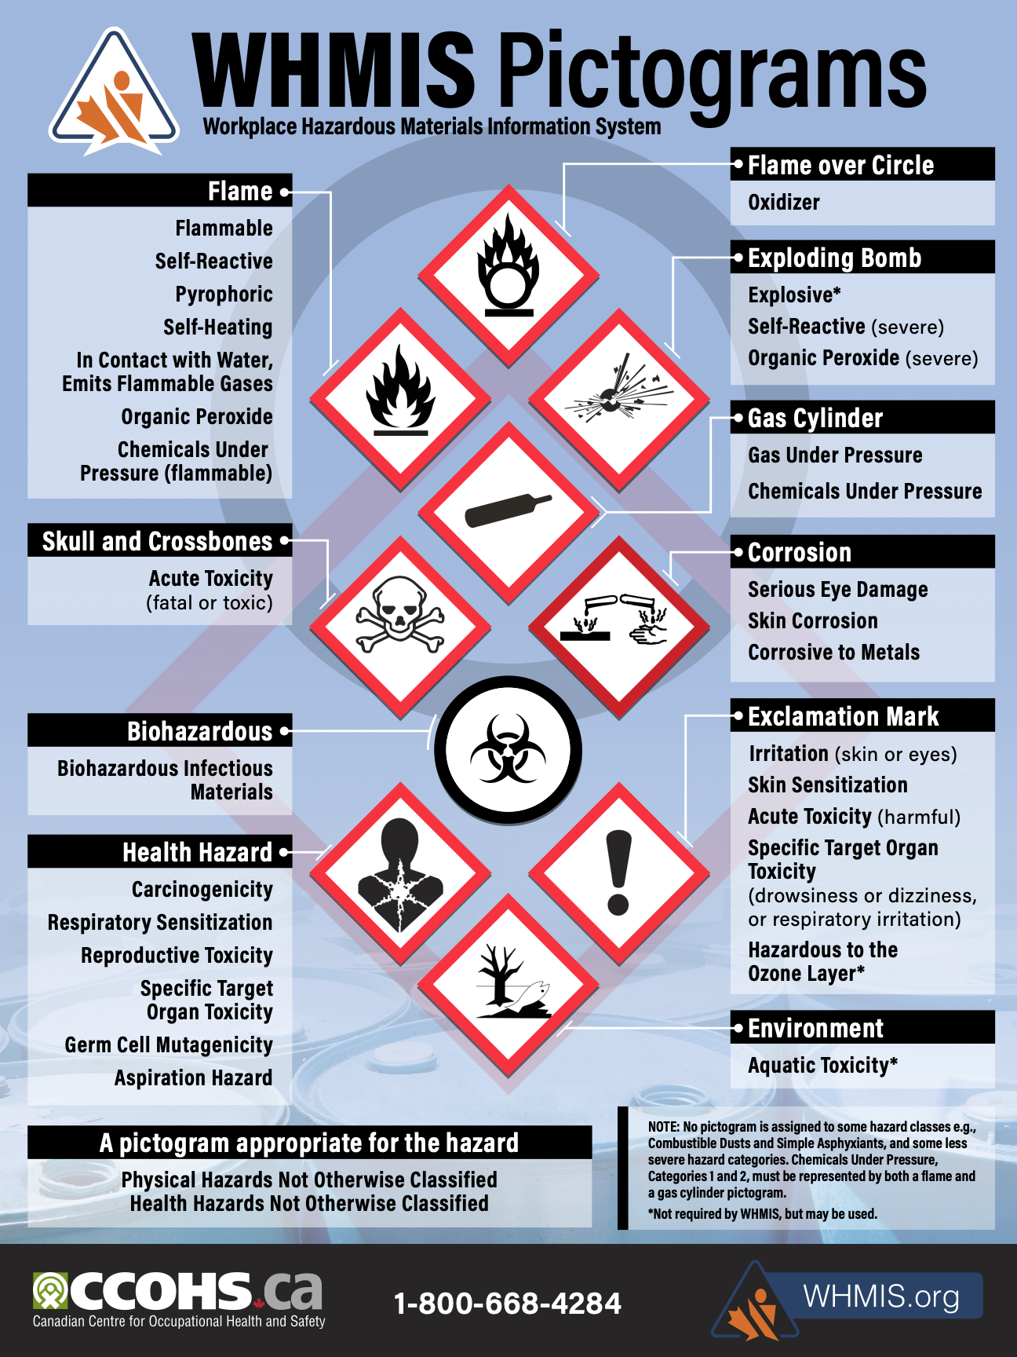

# Work Sheet

**Task 1: List three possible effects of Health Hazards.**

Answer:

**______________________________________________________**

**Task 2: Which two hazards list skin damage as an effect?**

Answer:

**______________________________________________________**

**Task 3: Which two hazards directly harm the environment?**

Answer:

**______________________________________________________**

**Task 4: Where could you find more information about hazard symbols and their effects?**

Answer:

**______________________________________________________**

# Answers

**Task 1: List three possible effects of Health Hazards.**

Answer: Any three of

* carcinogenicity
* respiratory sensitization
* reproductive toxicity
* specific target organ toxicity
* germ cell mutagenicity
* aspiration hazard

**Task 2: Which two hazards list skin damage as an effect?**

Answer: Corrosion (skin corrosion) and Exclamation Mark (skin sensitization)

**Task 3: Which two hazards directly harm the environment?**

Answer: Environment (aquatic toxicity) and Exclamation Mark (hazardous to the ozone layer).

**Task 4: Where could you find more information about hazard symbols and their effects?**

Answer: Any of the following: ccohs.ca; WHMIS.org; 1-800-668-4284

# Performance Descriptors

| Levels | Performance Descriptors | Needs Work | Completes task with support from practitioner | Completes task independently |
| --- | --- | --- | --- | --- |
| A2.2 | Performs limited searches using one or two search criteria |  |  |  |
|  | Uses layout to locate information |  |  |  |
|  | Makes low-level inferences |  |  |  |
|  | Makes connections between parts of documents |  |  |  |

This task: Was successfully completed Needs to be tried again

Learner Comments:

Instructor (print): Learner (print):

**__________________ _________________**