

Task Title: Write Text Message about Job Site Problem

# OALCF Cover Sheet – Practitioner Copy

**Learner Name:**

**Date Started:**

**Date Completed:**

|  |  |  |
| --- | --- | --- |
| **Goal Path:** | Employment | Apprenticeship |
| Secondary School | Post Secondary | Independence |

**Successful Completion:**  Yes No

**Task Description:**

Read and write a text message to solve a problem on a job site.

**Main Competency/Task Group/Level Indicator:**

* Find and Use Information/Read continuous text/A1.1
* Communicate Ideas and Information/Write continuous text/B2.1

**Materials Required:**

* Pen and Paper and/or digital device

# Learner Information

Communicating by text message is one way people communicate quickly with each other. Scan the text messages between a carpenter foreperson and their crew member.

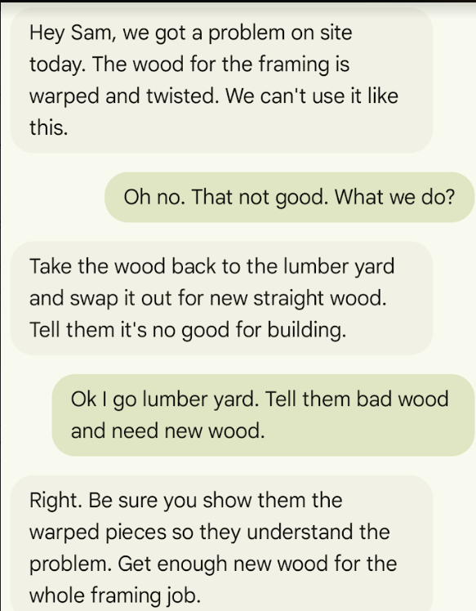

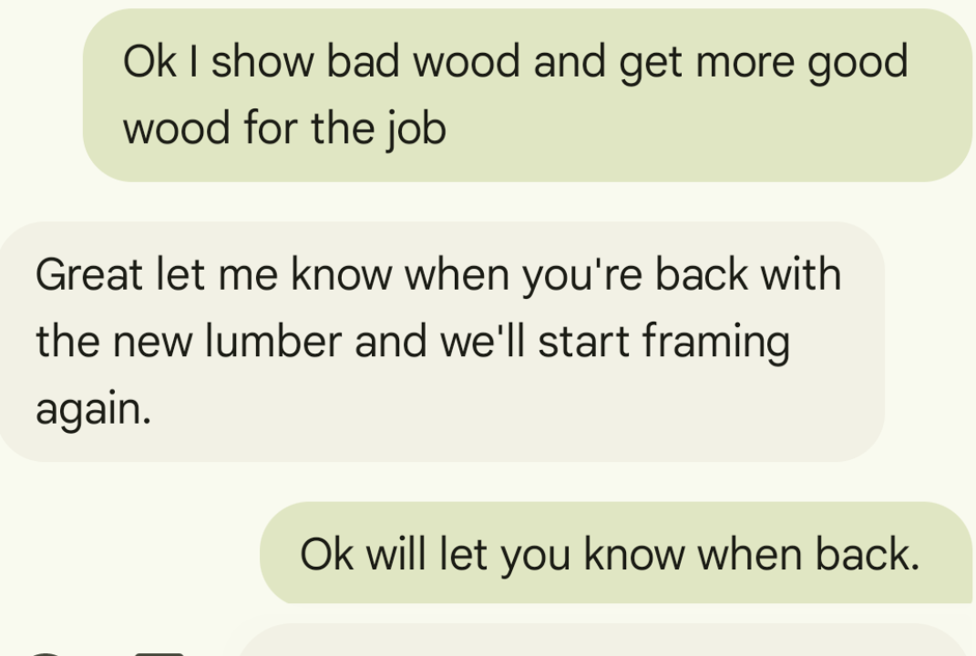

# Work Sheet

**Task 1: What is the problem with the wood?**

Answer:

**Task 2: What is the job they are using the wood for?**

Answer:

**Task 3: Where will Sam go to replace the bad wood with good wood?**

Answer:

**Task 4: Write a text message from Sam to tell the foreperson that he has returned to the job site with good wood.**

# Answers

**Task 1: What is the problem with the wood?**

Answer: It’s warped and twisted *(either one of these would suffice)*

**Task 2: What is the job they are using the wood for?**

Answer: They are using the wood for framing.

**Task 3: Where will Sam go to replace the bad wood with good wood?**

Answer: To the lumber yard.

**Task 4: Write a text message from Sam to tell the foreperson that he has returned to the job site with good wood.**

Answer: Accept anything similar to:

“I’m back with the good wood.”

# Performance Descriptors

| Levels | Performance Descriptors | Needs Work | Completes task with support from practitioner | Completes task independently |
| --- | --- | --- | --- | --- |
| A1.1 | Reads short texts to locate a single piece of information. |  |  |  |
| B2.1 | Writes simple texts to request, remind, or inform |  |  |  |

This task: Was successfully completed Needs to be tried again

Learner Comments:

Instructor (print): Learner (print):