Task-based Activity Cover Sheet
Task Title: Your Banking Options – Welcome to Libro
Learner Name:

Date Started: Date Completed:

Successful Completion: Yes □ No □
Goal Path: Employment □ Apprenticeship □ Secondary School □ Post-Secondary □ Independence X
Task Description:
Learners will understand about additional services Libro provides its members.
Competency:  A: Find and Use Information | Task Group(s):  A1: Read continuous text
Level Indicators:
A1.1: Read brief texts to locate specific details
A1.2: Read texts to locate and connect ideas and information

Performance Descriptors: see chart on last page
Materials Required:
- Pencil or pen
- Computer/Laptop/Mobile Device if done online using Google docs

Task Title: Your Banking Options – Welcome to Libro
Credit Unions and Banks have brochures that help customers understand what services they provide. Look at the handout “Welcome to Libro”.
Learner Information and Tasks:
Task 1: List 5 Additional Services that Libro provides to its customers.

Task 2: How does Libro make decisions?

Task 3: What does a Libro Coach do?

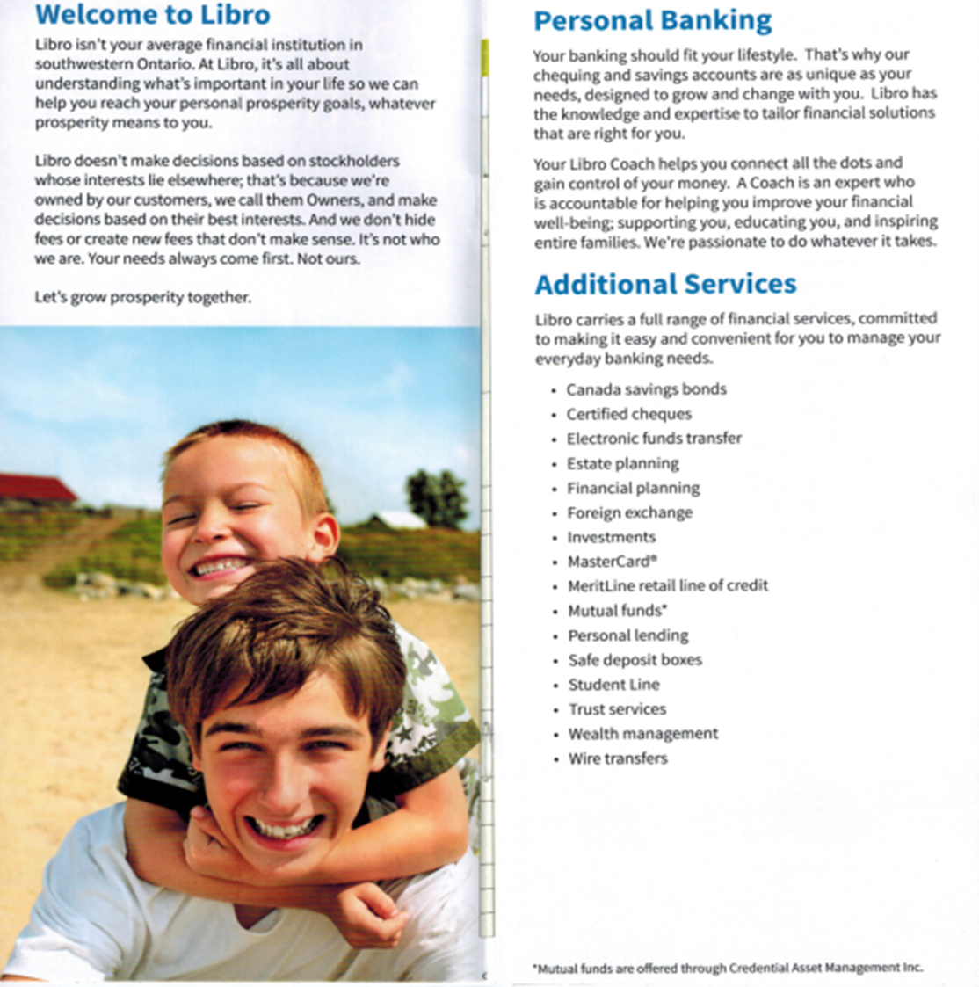
Task Title: Your Banking Options – Welcome to Libro
Answer Key
Task 1: List 5 Additional Services that Libro provides to its customers.
A: Any 5 of the 16 listed in the article
Task 2: How does Libro make decisions?
A: they make decisions based on their owners’ (customers’) best interests
Task 3: What does a Libro Coach do?
A: helps you connect the dots and gain control of your money

Task Title: Your Banking Options – Welcome to Libro
Performance Descriptors |  | Needs Work | Completes task with support from practitioner | Completes task independently
A1.1 | - reads short texts to locate a single piece of information
A1.2 | - scans text to locate information
 | - locates multiple pieces of information in simple texts

This task: was successfully completed □ needs to be tried again □

Learner Comments

____________________________ _________________________

Instructor (print) Learner Signature

